Nails & Pedicures

More Than a Manicure. A Signature of Confidence.
Your hands are one of the first things people notice, and beautifully maintained nails are more than a finishing touch—they're a reflection of confidence, self-care, and attention to detail.
At LUNA Beauty Studio, we don't believe in rushed appointments or one-size-fits-all treatments. Every manicure and pedicure is carefully tailored to your natural nails, lifestyle, and personal preferences, ensuring results that are not only beautiful on the day of your appointment but remain elegant and durable for weeks to come.
Our technicians are trained in advanced Russian Manicure techniques, renowned for their precision, flawless cuticle work, and immaculate finish. Every treatment begins with a detailed assessment of your nails, allowing us to recommend the most suitable service—whether that's BIAB, Rubber Base, Hard Gel, Gel Extensions, or a bespoke nail enhancement designed specifically for you.
We believe healthy nails are the foundation of beautiful nails. That's why we use premium professional products, safe techniques, and meticulous application methods that protect the natural nail while delivering exceptional strength, durability, and a flawless finish.
Our pedicure treatments are designed with the same philosophy. Beyond perfectly polished toes, we focus on the health, comfort, and appearance of your feet. From meticulous cuticle work and nail care to smooth heels and beautifully finished toes, every pedicure is performed with exceptional attention to detail in a relaxing and hygienic environment.
Whether you prefer timeless elegance, modern minimalism, intricate nail art, or bold statement designs, our goal is always the same—to create nails that reflect your personality while maintaining the highest standards of quality and craftsmanship.
At LUNA Beauty Studio, luxury isn't about excess. It's about precision, expertise, and making every client feel welcomed, valued, and confident from the moment they walk through our doors.

Why Clients Choose LUNA Beauty Studio
✨ Russian Manicure specialists renowned for exceptional cuticle work.
✨ Luxury manicures and pedicures tailored to your lifestyle and nail health.
✨ Premium professional products from trusted industry brands.
✨ A healthy nail-first approach focused on long-lasting results.
✨ Meticulous attention to detail and bespoke nail artistry.
✨ Fully sterilised instruments and uncompromising hygiene standards.
✨ Experienced technicians committed to continuous education and excellence.
✨ A welcoming, luxury salon experience where every appointment is designed around you.

Rubber Base (dana,tanya,lola)
Manicure A strengthening rubber base manicure designed to reinforce natural nails, improve durability, and create a flawless, long-lasting finish.

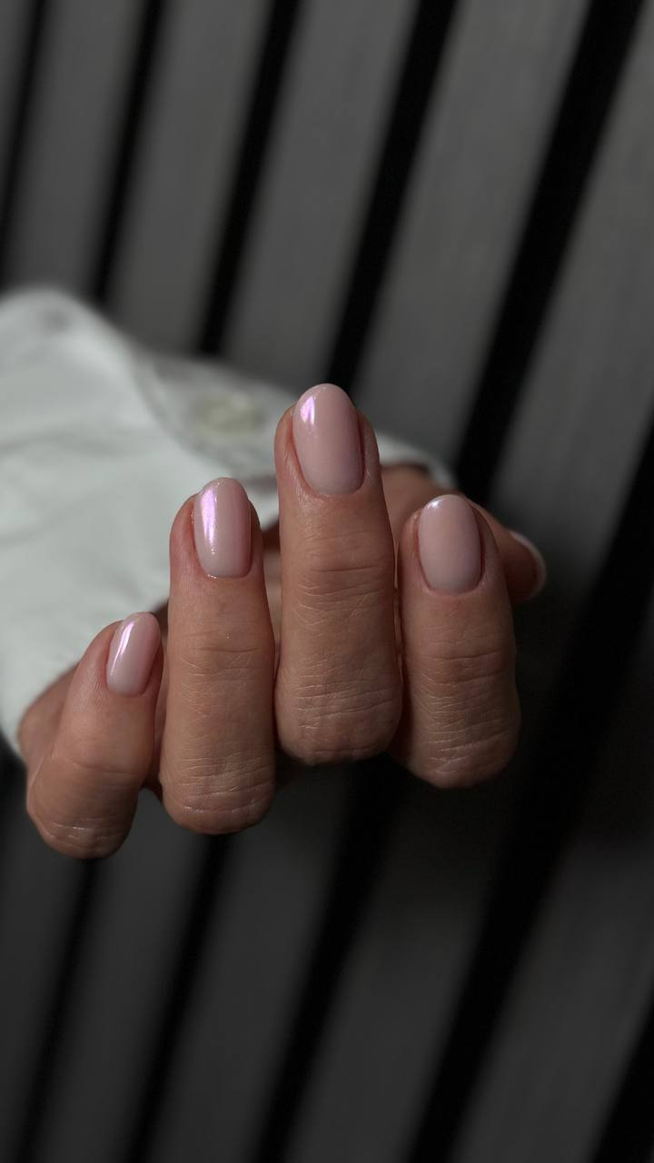

French Tip (dana,tanya,lola)
A timeless French manicure with a clean, precise tip — elegant, balanced, and effortlessly sophisticated.
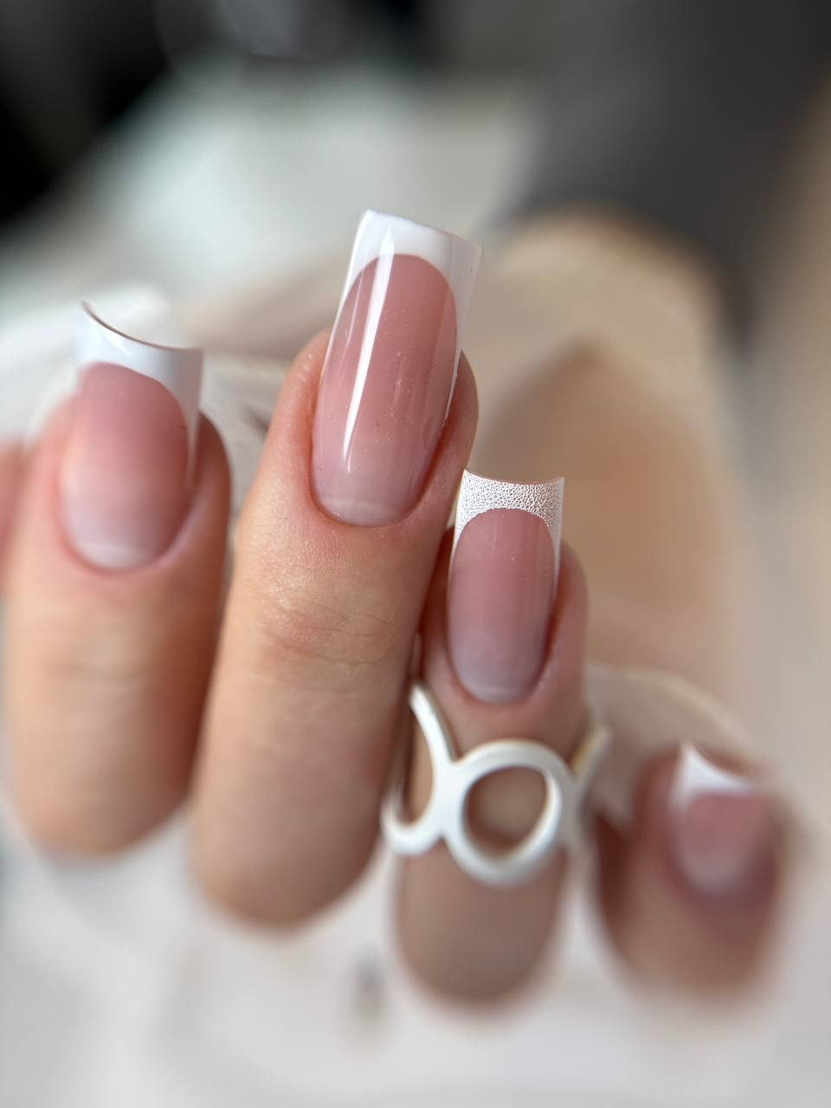

Extensions (dana,tanya,lola)
Structured nail extensions crafted for strength, symmetry, and refined shape — tailored to a natural or statement finish.

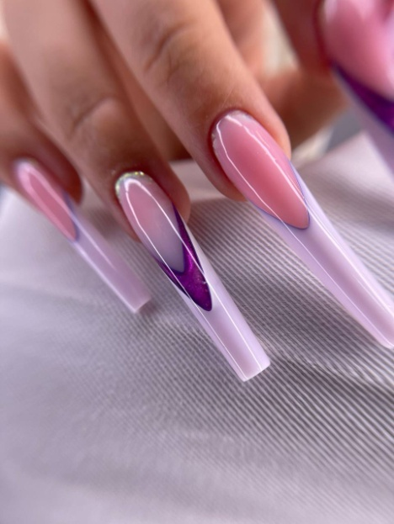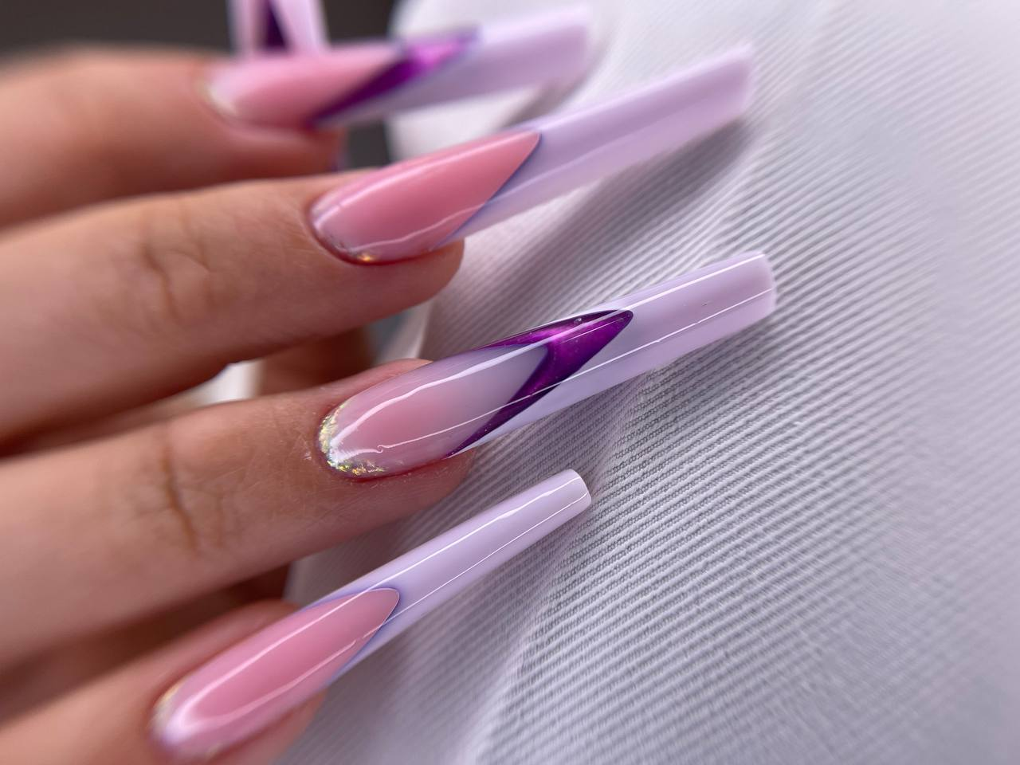
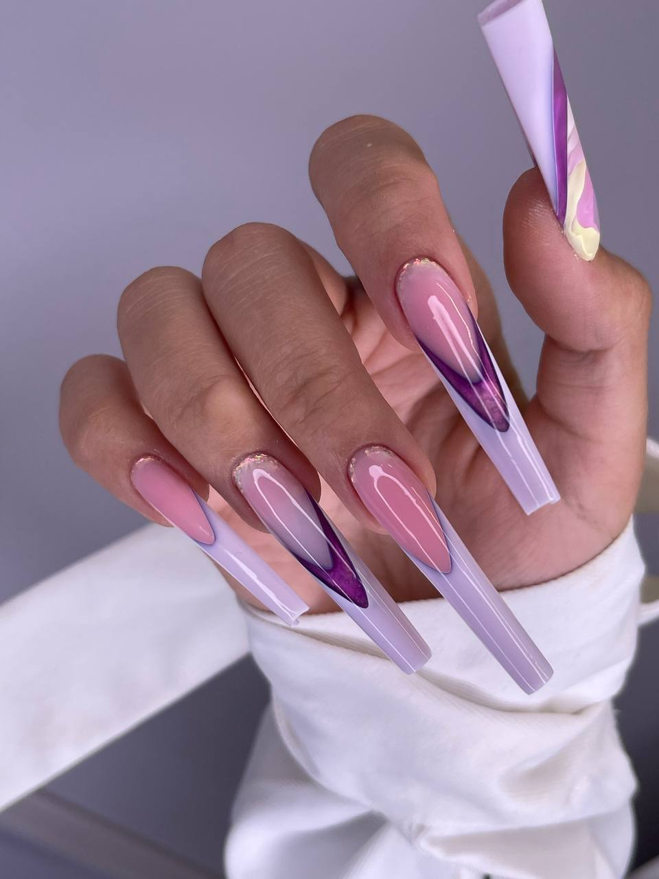
Clean Manicure(dana.tanya.lola)
A meticulous nail preparation focused on cuticle care and nail health — clean, minimal, and perfectly refined.
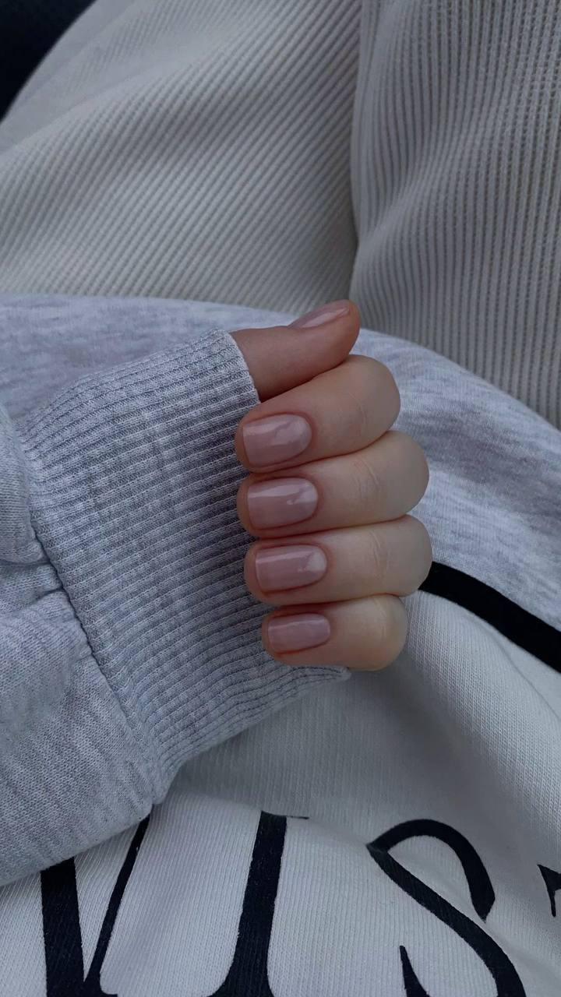

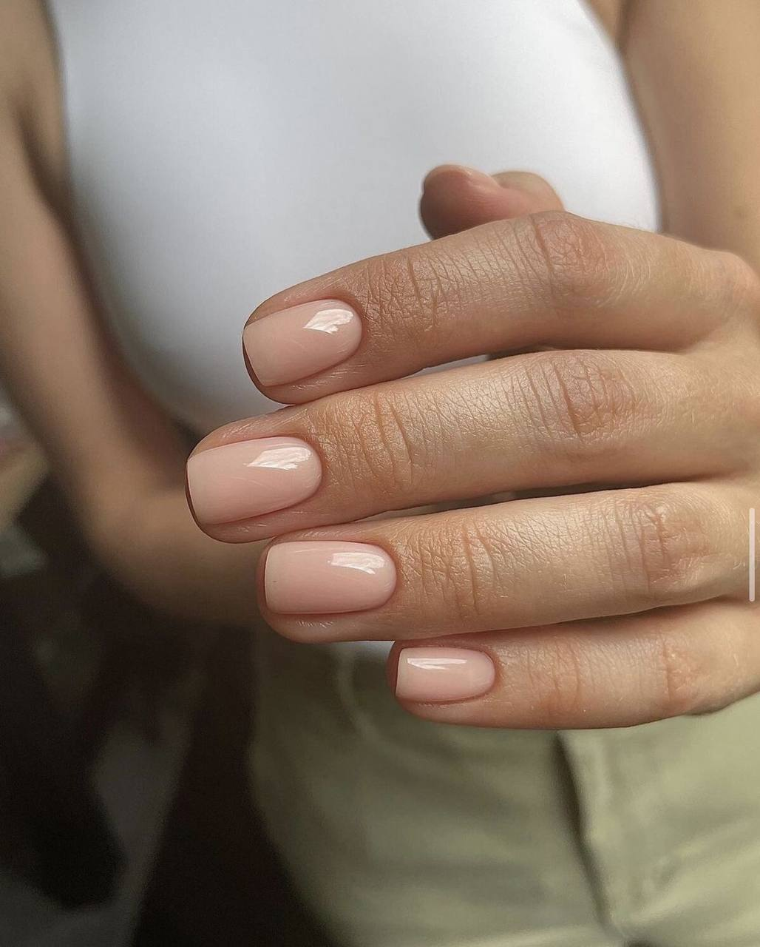

Aesthetic Pedicure (dana.tanya.lola)
A refined pedicure focused on clean lines, healthy skin, and a polished, elegant finish.
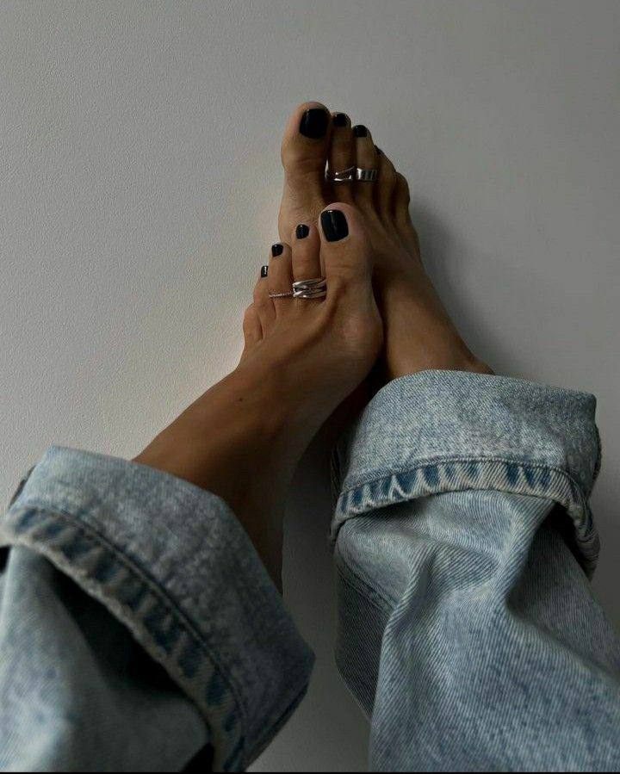
Ingrown Toenails (dana only)
Treatment Professional and gentle treatment to relieve discomfort and restore nail health with precision and care.
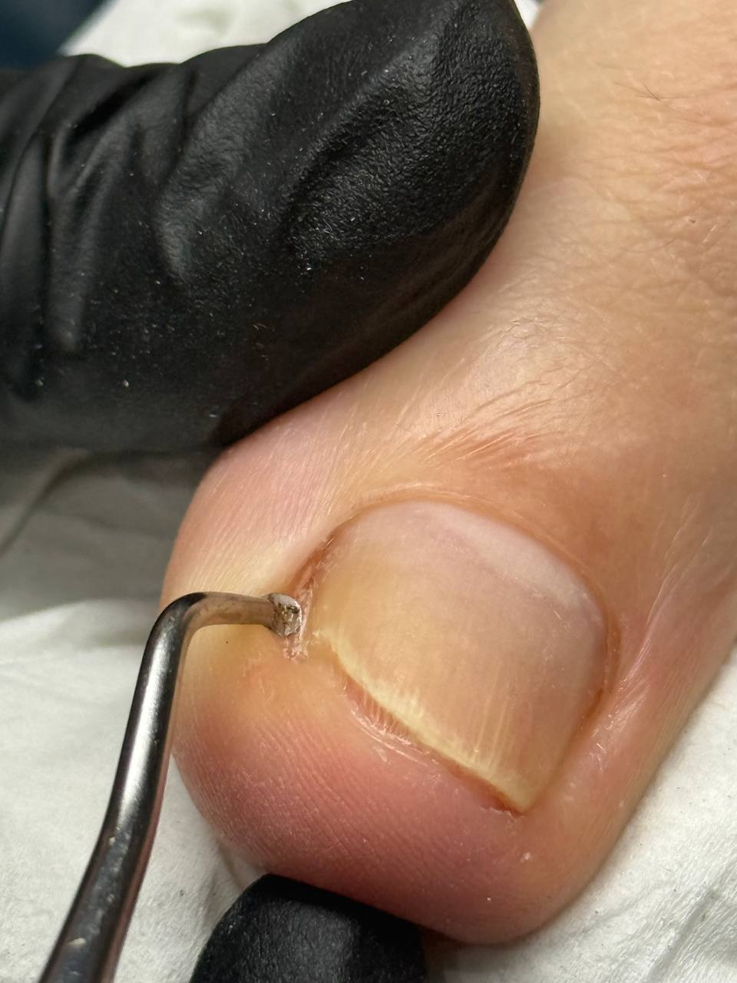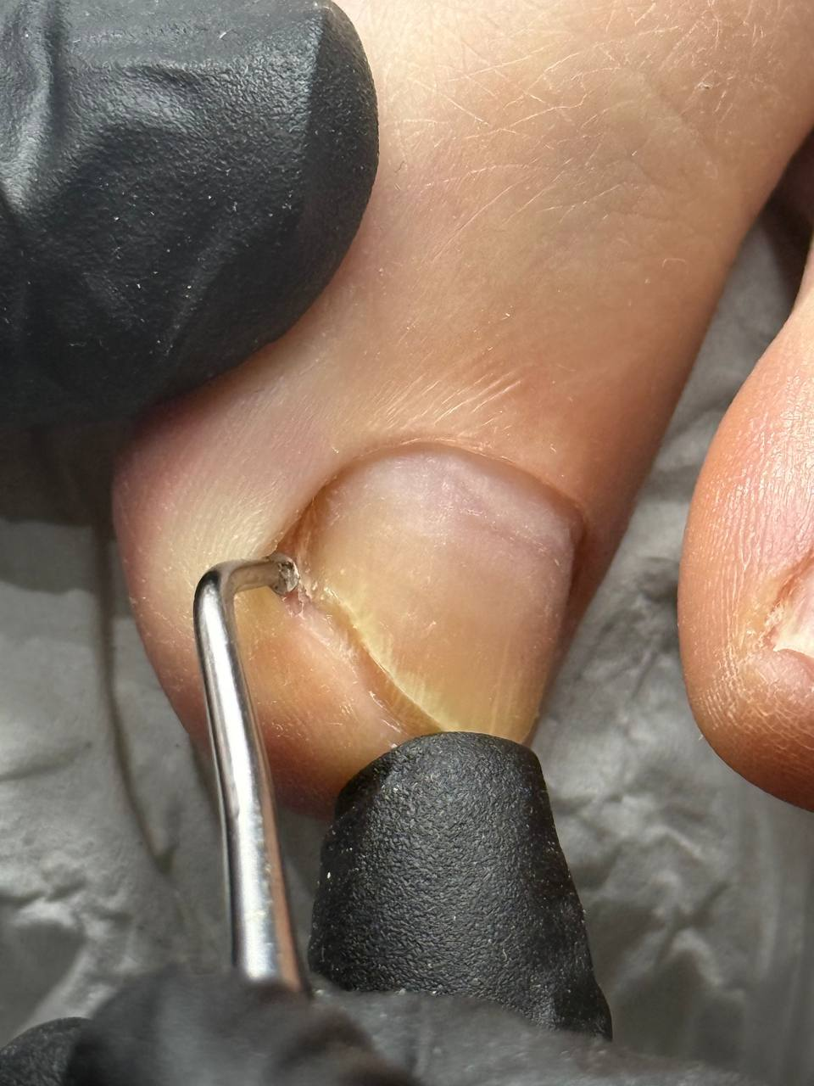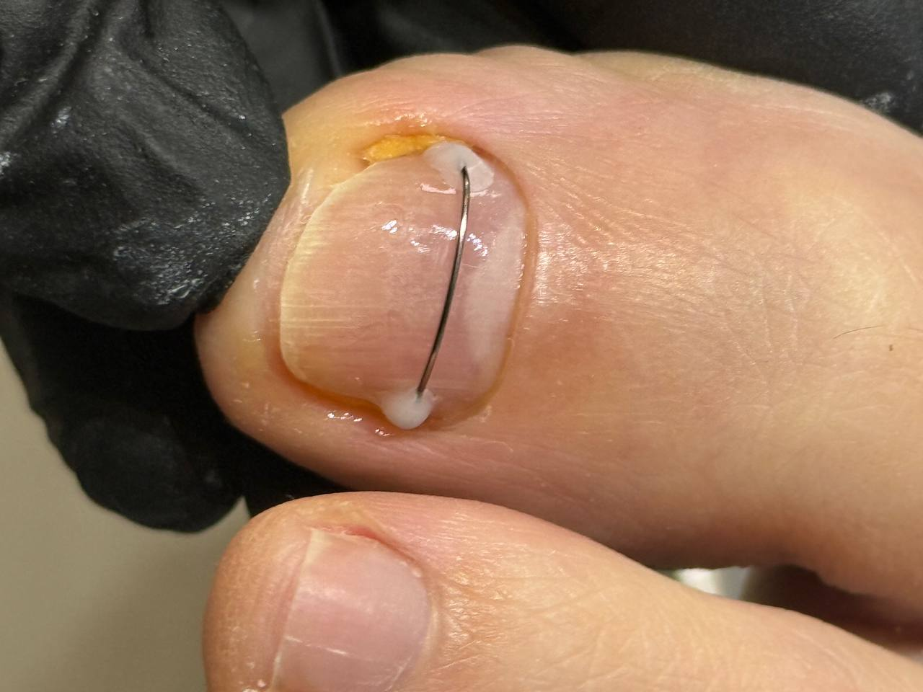
Cracked Heels Treatment (dana.tanya.lola)
Intensive care to repair dry, cracked heels — smoothing, hydrating, and restoring softness.
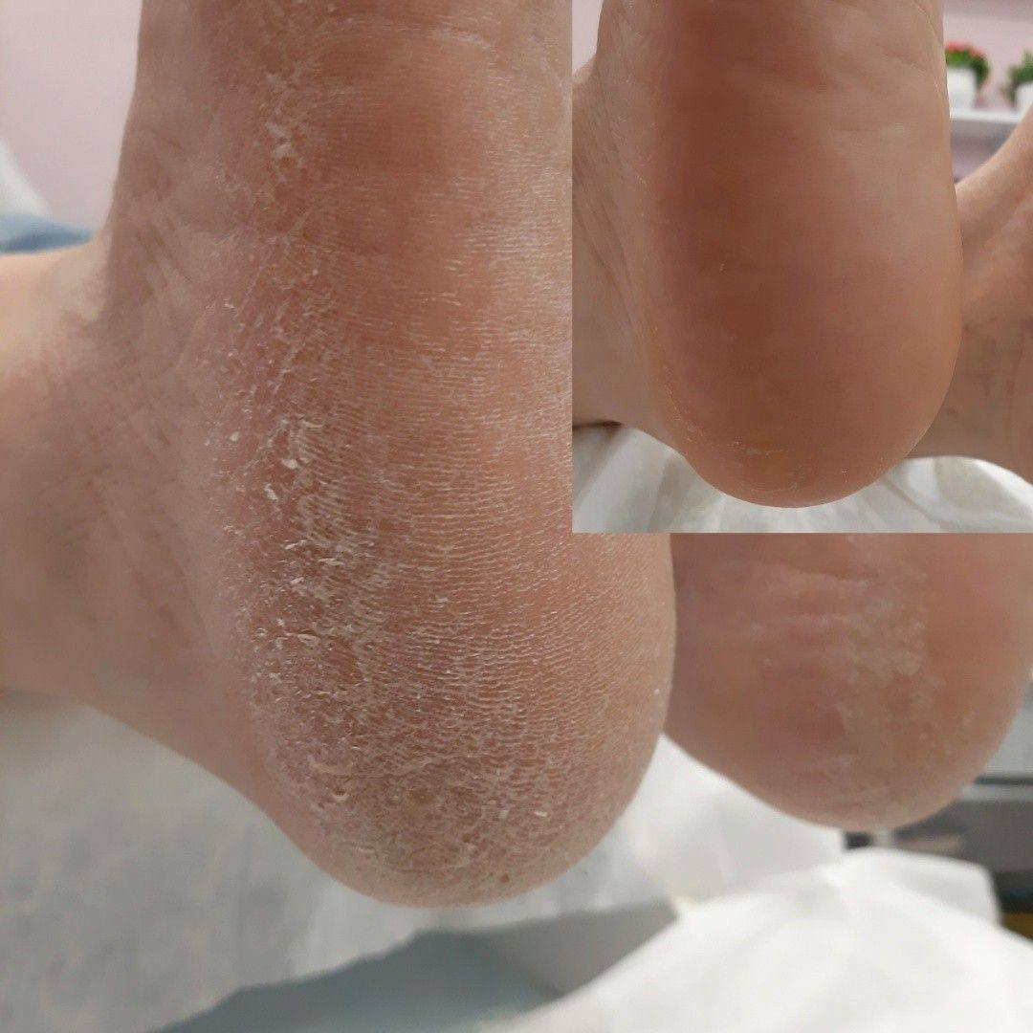

Meet Dana
Hi, I'm Dana, the founder of LUNA Beauty Studio & Academy.
With over 12 years of experience in the beauty industry, my passion has always been to deliver exceptional results while raising the standards of professionalism, education and client care.
My journey began with a simple fascination for beautiful nails, but it quickly became much more than that. Through years of continuous education, hands-on experience and working in different countries, I developed a deep understanding that beauty isn't just about how something looks—it's about precision, health, confidence and trust.
That vision inspired me to create LUNA Beauty Studio: a luxury space where every client feels welcomed, listened to and genuinely cared for. We believe that every appointment should be more than just a treatment—it should be an experience where quality is never compromised.
Today, together with my talented team, we specialise in luxury nail services, Russian manicures, pedicures, brows, lashes, waxing, permanent makeup and professional makeup. Every service is performed with attention to detail, premium products and a commitment to maintaining the highest hygiene standards.
As an educator and founder of LUNA Academy, I continue to train future beauty professionals because I believe education is the foundation of excellence. By constantly learning and sharing knowledge, we ensure that every client who visits LUNA benefits from the latest techniques, safest practices and the highest level of expertise.
One of the things I value most is building genuine relationships with my clients. Many of them have been with us for years, and their trust is what inspires me to keep growing, improving and creating an environment where everyone feels comfortable and confident.
For me, beauty is not about following trends—it's about enhancing your natural beauty, helping you feel your best, and giving you a moment to relax in the middle of a busy life.
Whether you're visiting us for your very first appointment or you've been part of the LUNA family for years, my promise remains the same: exceptional quality, honest advice, meticulous attention to detail, and an experience you'll always look forward to.
I look forward to welcoming you to LUNA Beauty Studio.
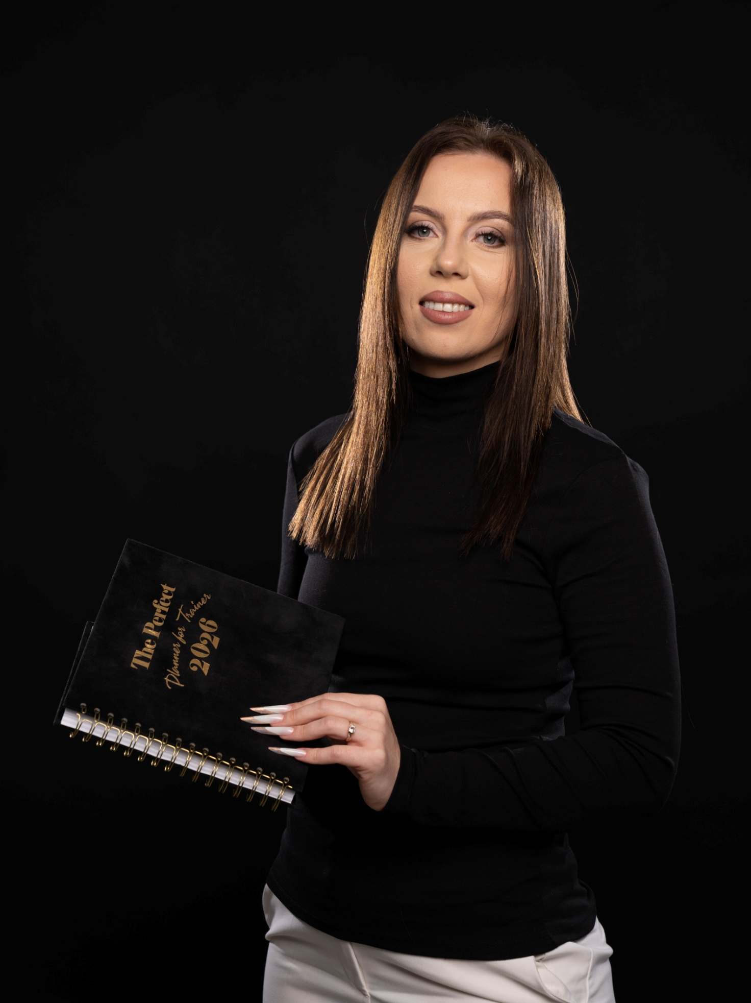
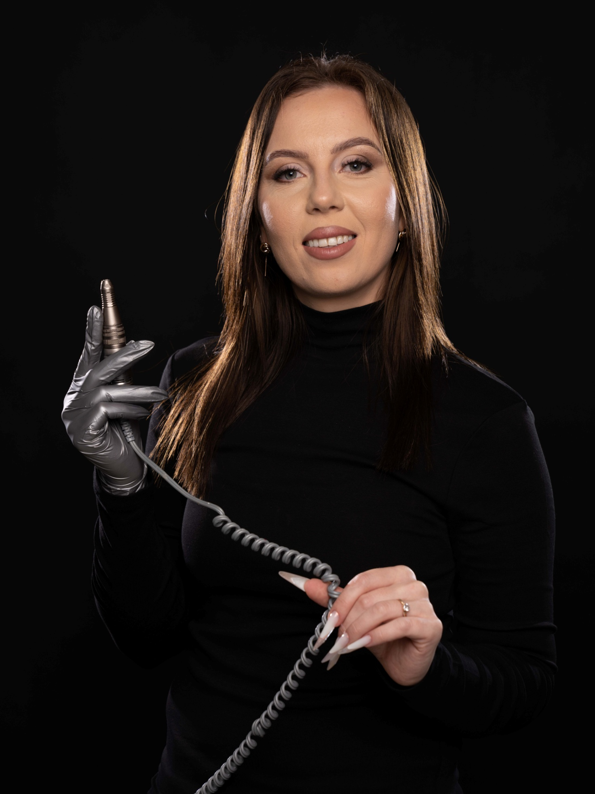
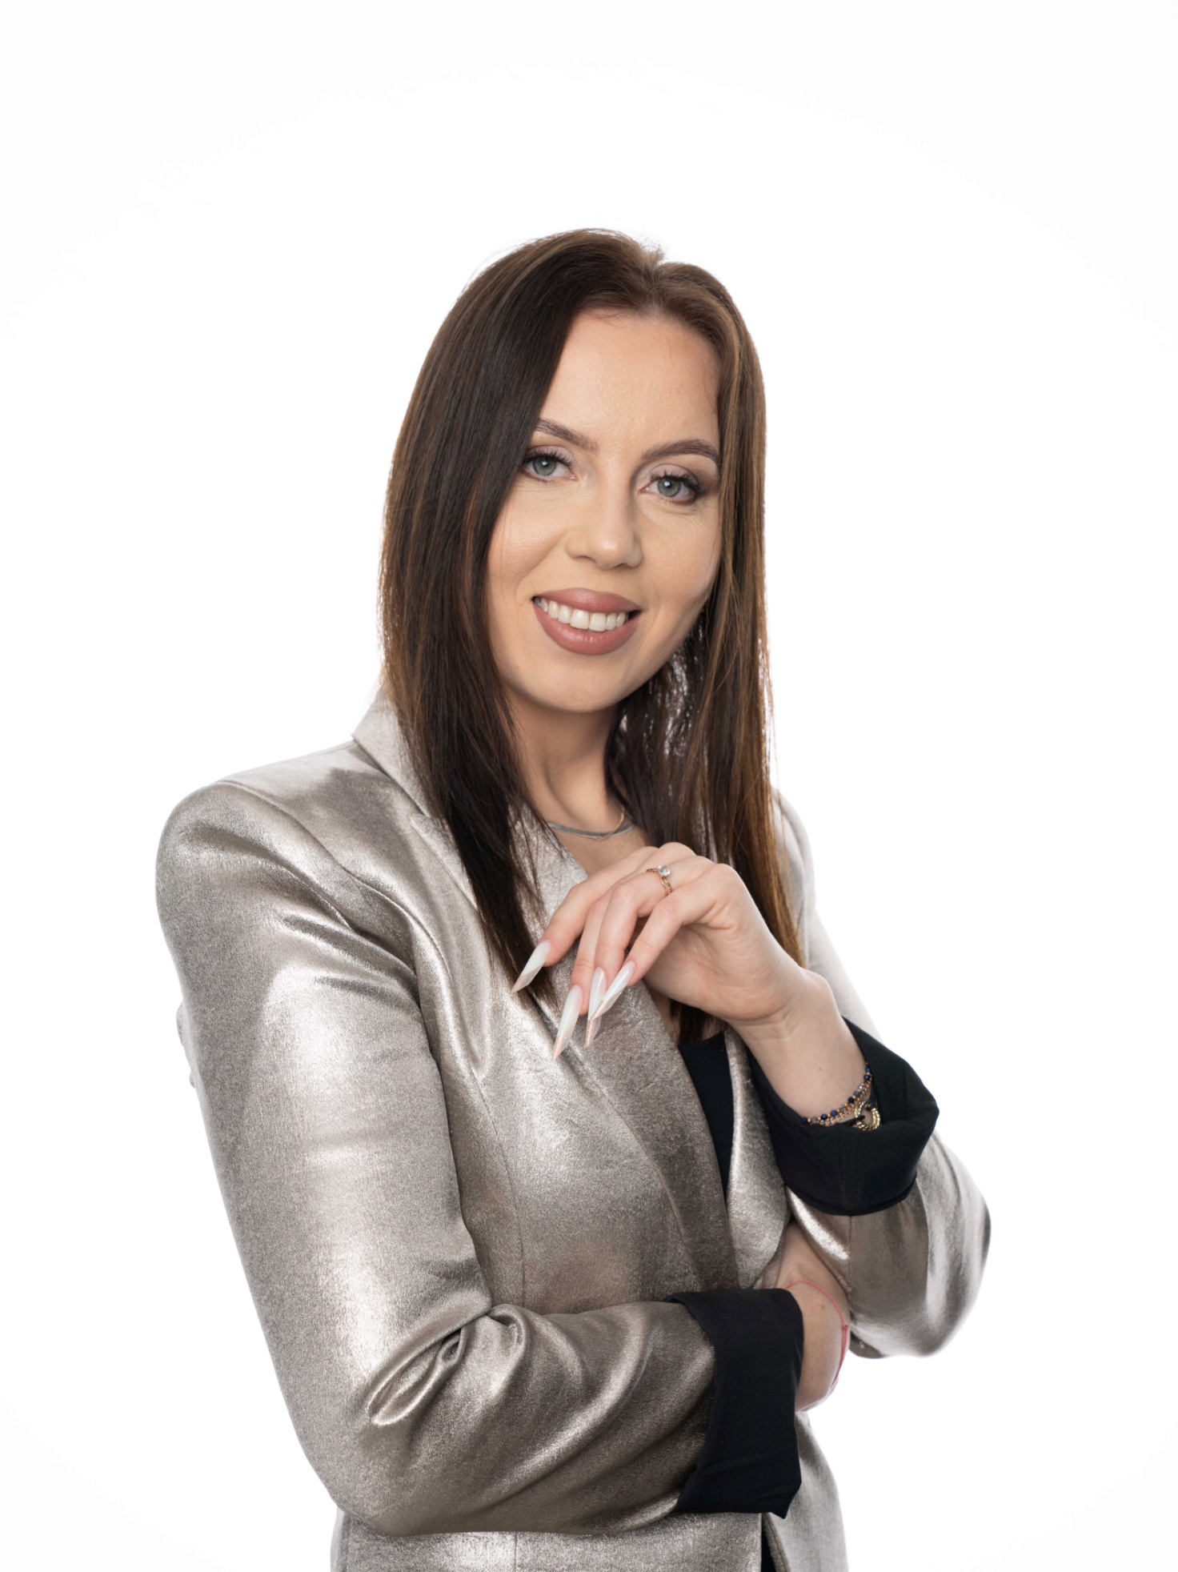

Bridal Makeup
Our Bridal Makeup service is fully tailored to your personal style, dress, and wedding theme. Whether you dream of a soft, romantic glow, timeless elegance, or full glamorous perfection, we create a flawless complexion and long-lasting finish designed to withstand happy tears, endless photos, and hours of celebration. Every product is carefully selected for durability and comfort,ensuring you look radiant from the first look until the last dance.

( We recommend every bride books a Bridal Makeup Trial before the wedding day. This personalised consultation allows us to refine your chosen look, test products, and ensure every detail is tailored to you. When you're ready, simply reserve your trial through our online booking system, or get in touch to discuss a bespoke bridal experience.)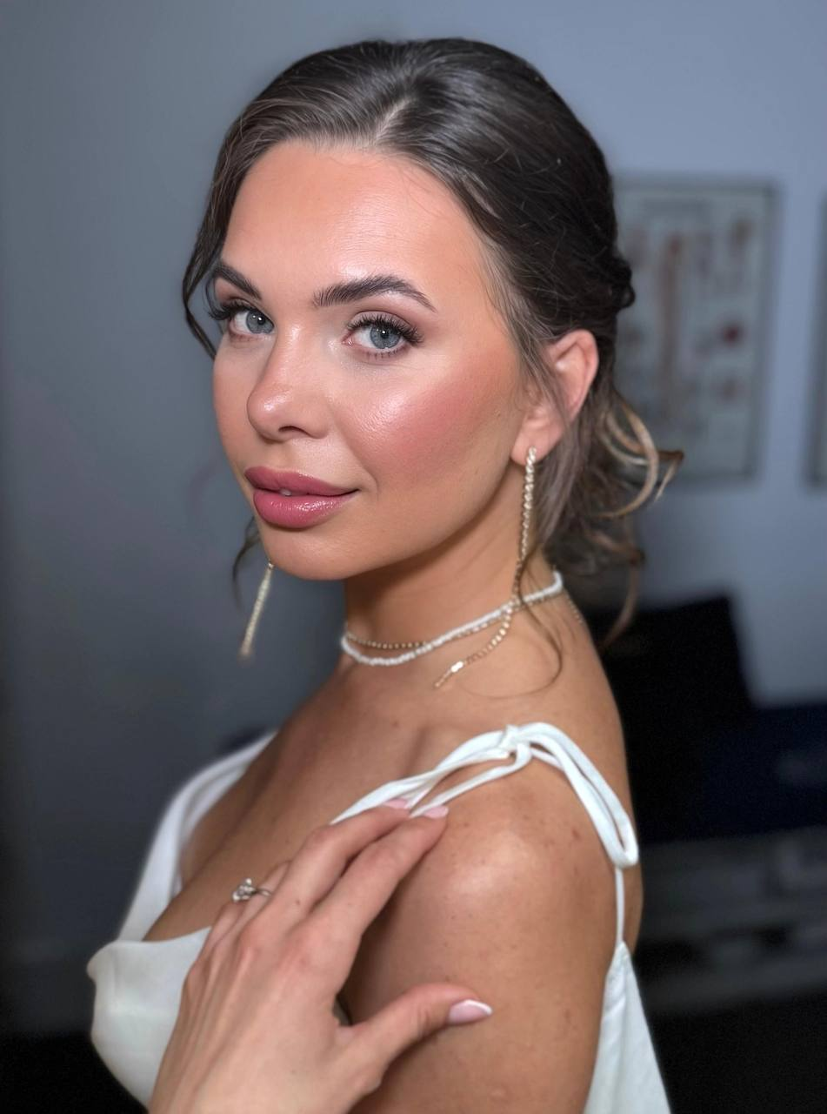

Bridesmaids Makeup
Beautifully coordinated makeup designed to complement the bride and the wedding aesthetic while enhancing each bridesmaid's individual features. Every look is customised to suit different skin tones, face shapes, and personal styles, creating an elegant bridal party that photographs beautifully together while allowing everyone to feel confident and comfortable.
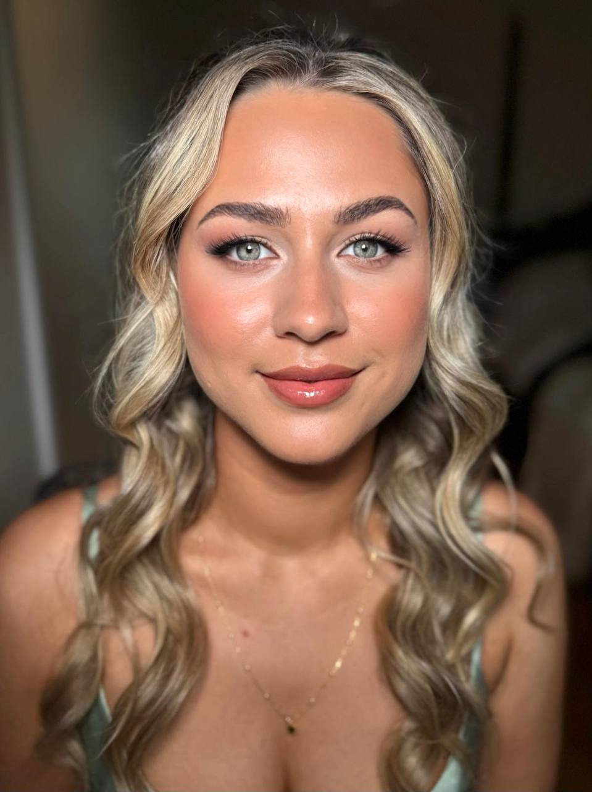

Flower Girl Makeup
A soft, delicate touch of age-appropriate makeup designed to make your little one feel extra special. Using gentle products and subtle shimmer, blush, or lip gloss, we create a fresh, natural look that enhances photos while keeping your flower girl comfortable and looking like herself.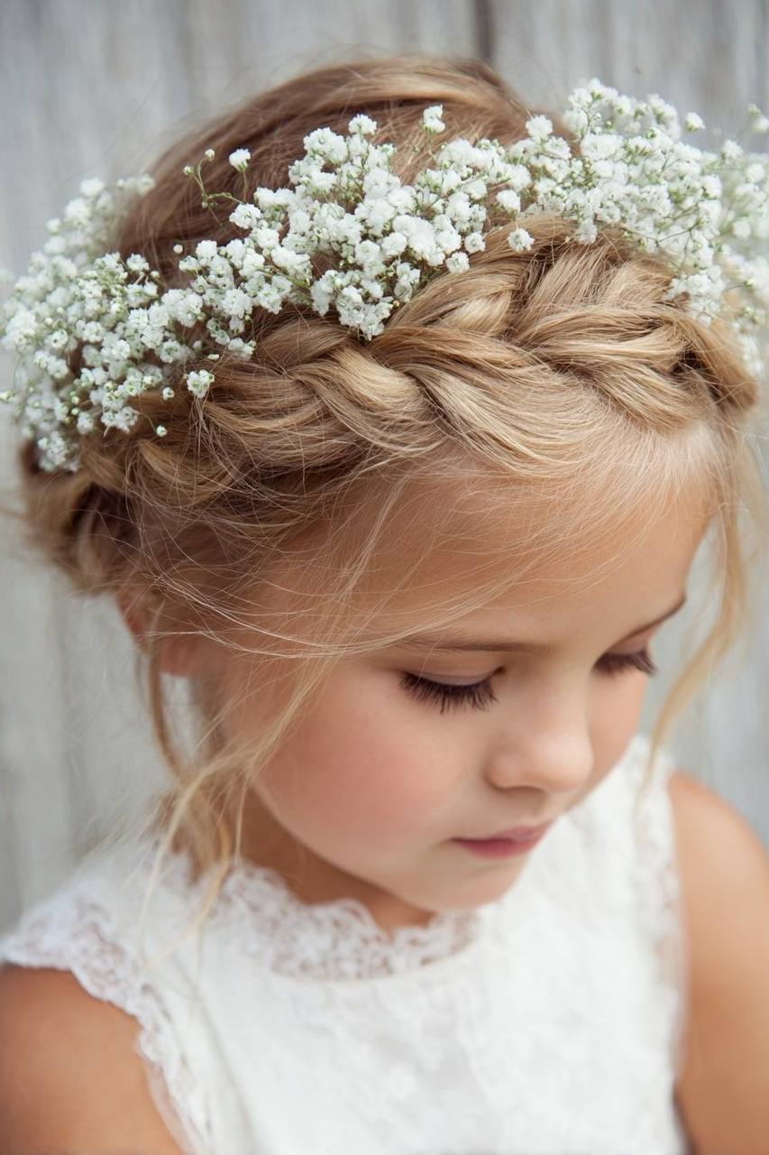

Soft / Natural Makeup
Perfect for clients who love understated elegance. This look enhances your natural beauty using lightweight, skin-like products that create a radiant complexion, softly defined eyes, and fresh, healthy-looking skin. Ideal for daytime events, business shoots, baby showers, brunches, or anyone wanting an effortlessly polished appearance.
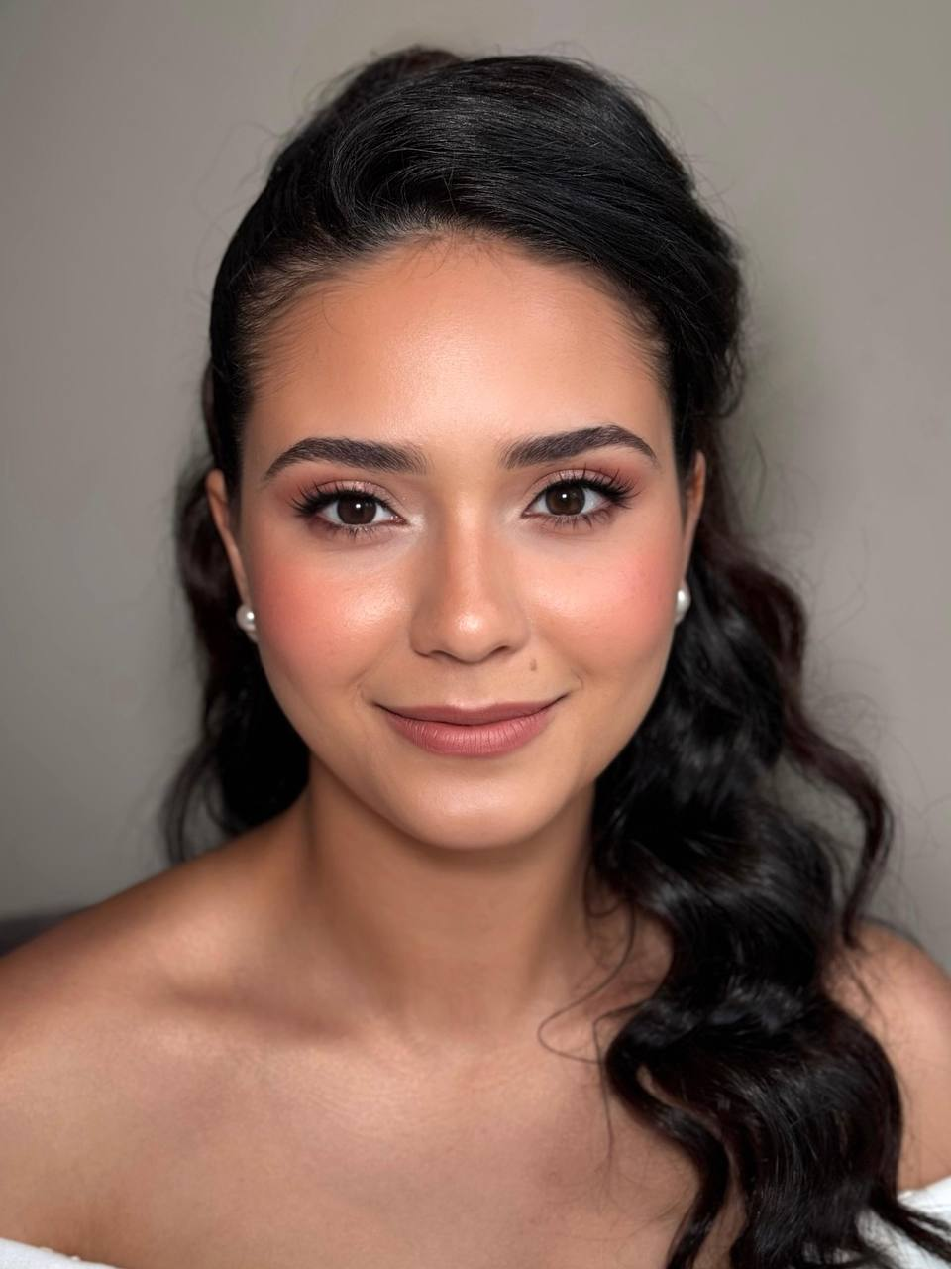

Special Occasion Makeup
Whether you're attending a wedding, celebrating a birthday, prom, gala, engagement party, or any important event, our Special Occasion Makeup is customised to suit your outfit, hairstyle, lighting, and personal style. Expect a flawless, long-lasting finish that photographs beautifully and lasts comfortably throughout the entire event.
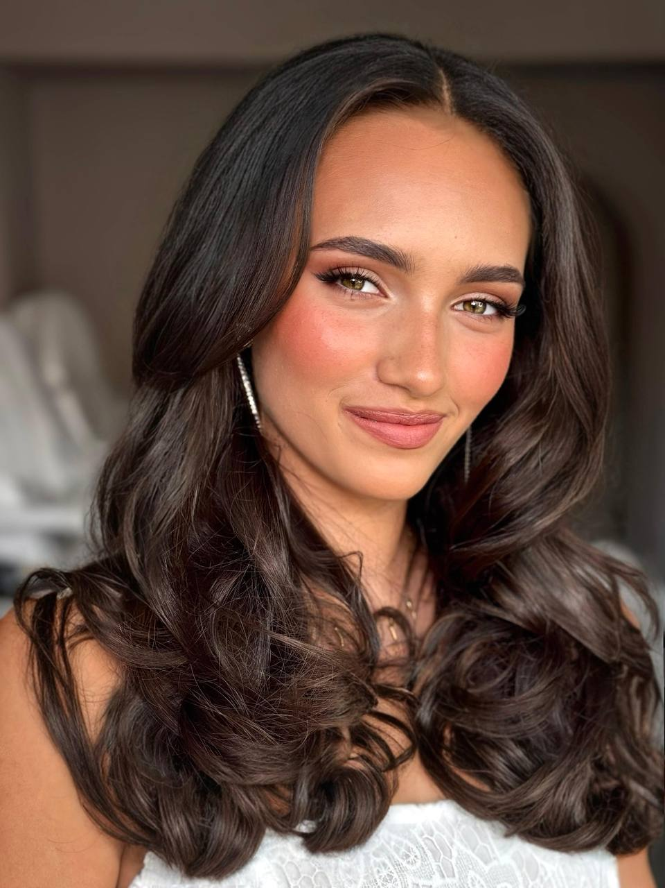

Editorial & Photoshoot Makeup
Designed specifically for professional photography, branding sessions, fashion editorials, commercial campaigns, and content creation. This high-definition makeup is carefully crafted to perform beautifully under studio lighting and high-resolution cameras, with precise contouring, skin perfection, and expert detailing that translates flawlessly both on camera and in person.
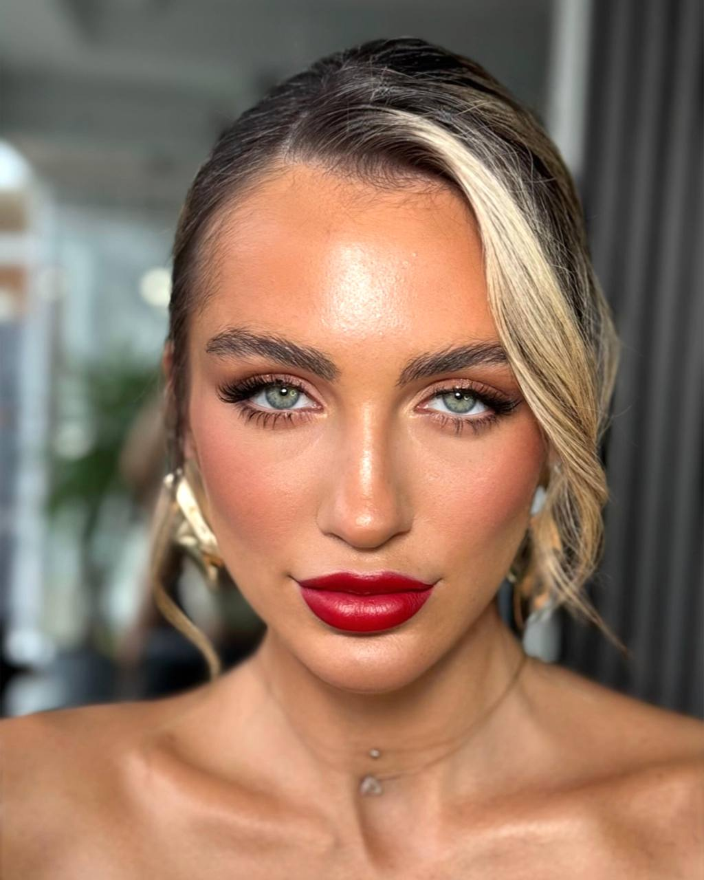
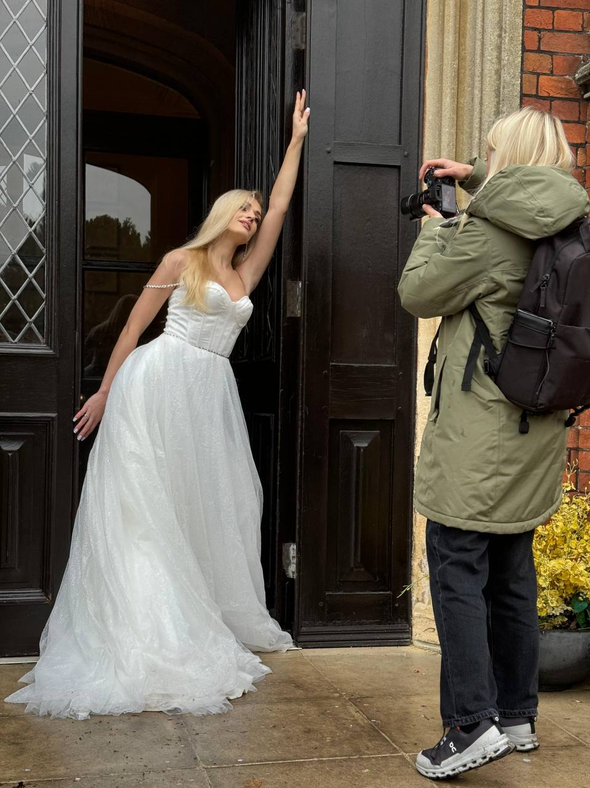

Meet Nelya – Professional Makeup Artist
With over 4 years of experience in the beauty industry, Nelya is a dedicated and passionate makeup artist committed to enhancing each client's natural beauty with precision and artistry.
Specialising in bridal, occasion, and editorial makeup, she creates elegant, long-lasting looks tailored to each individual's features, style, and vision. Whether you prefer a soft, radiant finish or timeless glamour, Nelya takes the time to understand your expectations and deliver results that make you feel confident and beautiful.
Known for her professionalism, attention to detail, and calm, friendly approach, she believes every appointment should be a relaxing and enjoyable experience. Her client-focused philosophy ensures that every look is personalised, comfortable to wear, and flawlessly executed.
Fluent in English and Russian, Nelya welcomes clients from diverse backgrounds and is dedicated to providing exceptional service from consultation to the final touch.
At LUNA Beauty Studio, Nelya is proud to help every client look and feel their absolute best for life's most memorable moments.

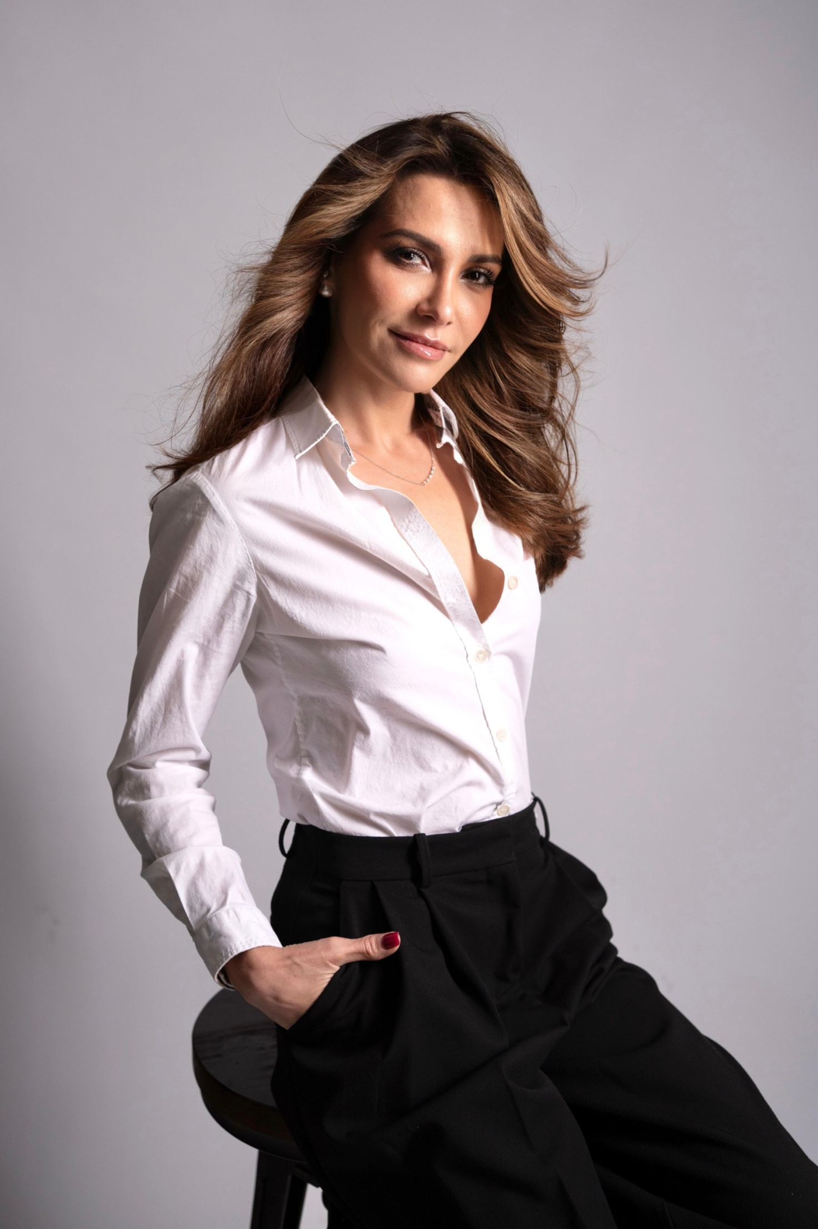

Meet Tanya – Nail Technician
What once seemed impossible has become Tanya's passion and profession. She never imagined herself working in the nail industry, but taking that first step changed her life.
With over 4 years of experience, Tanya specialises in creating beautiful, long-lasting nails with precision, care, and exceptional attention to detail. From once feeling nervous about holding an e-file to becoming a trusted nail technician known for clean Russian manicures and refined cuticle work, her journey is a testament to dedication, perseverance, and continuous growth.
Tanya believes every client deserves healthy, durable nails that remain beautiful long after leaving the salon. Her meticulous approach, combined with an artistic eye and commitment to quality, allows her to create elegant manicures that are both practical and long-lasting.
Passionate about continuous education, Tanya is always refining her techniques and staying up to date with the latest industry standards to provide the highest level of care and craftsmanship.
Fluent in English and Russian, and currently learning Spanish, she enjoys welcoming clients from different backgrounds and creating a warm, relaxing experience for everyone who visits LUNA Beauty Studio.
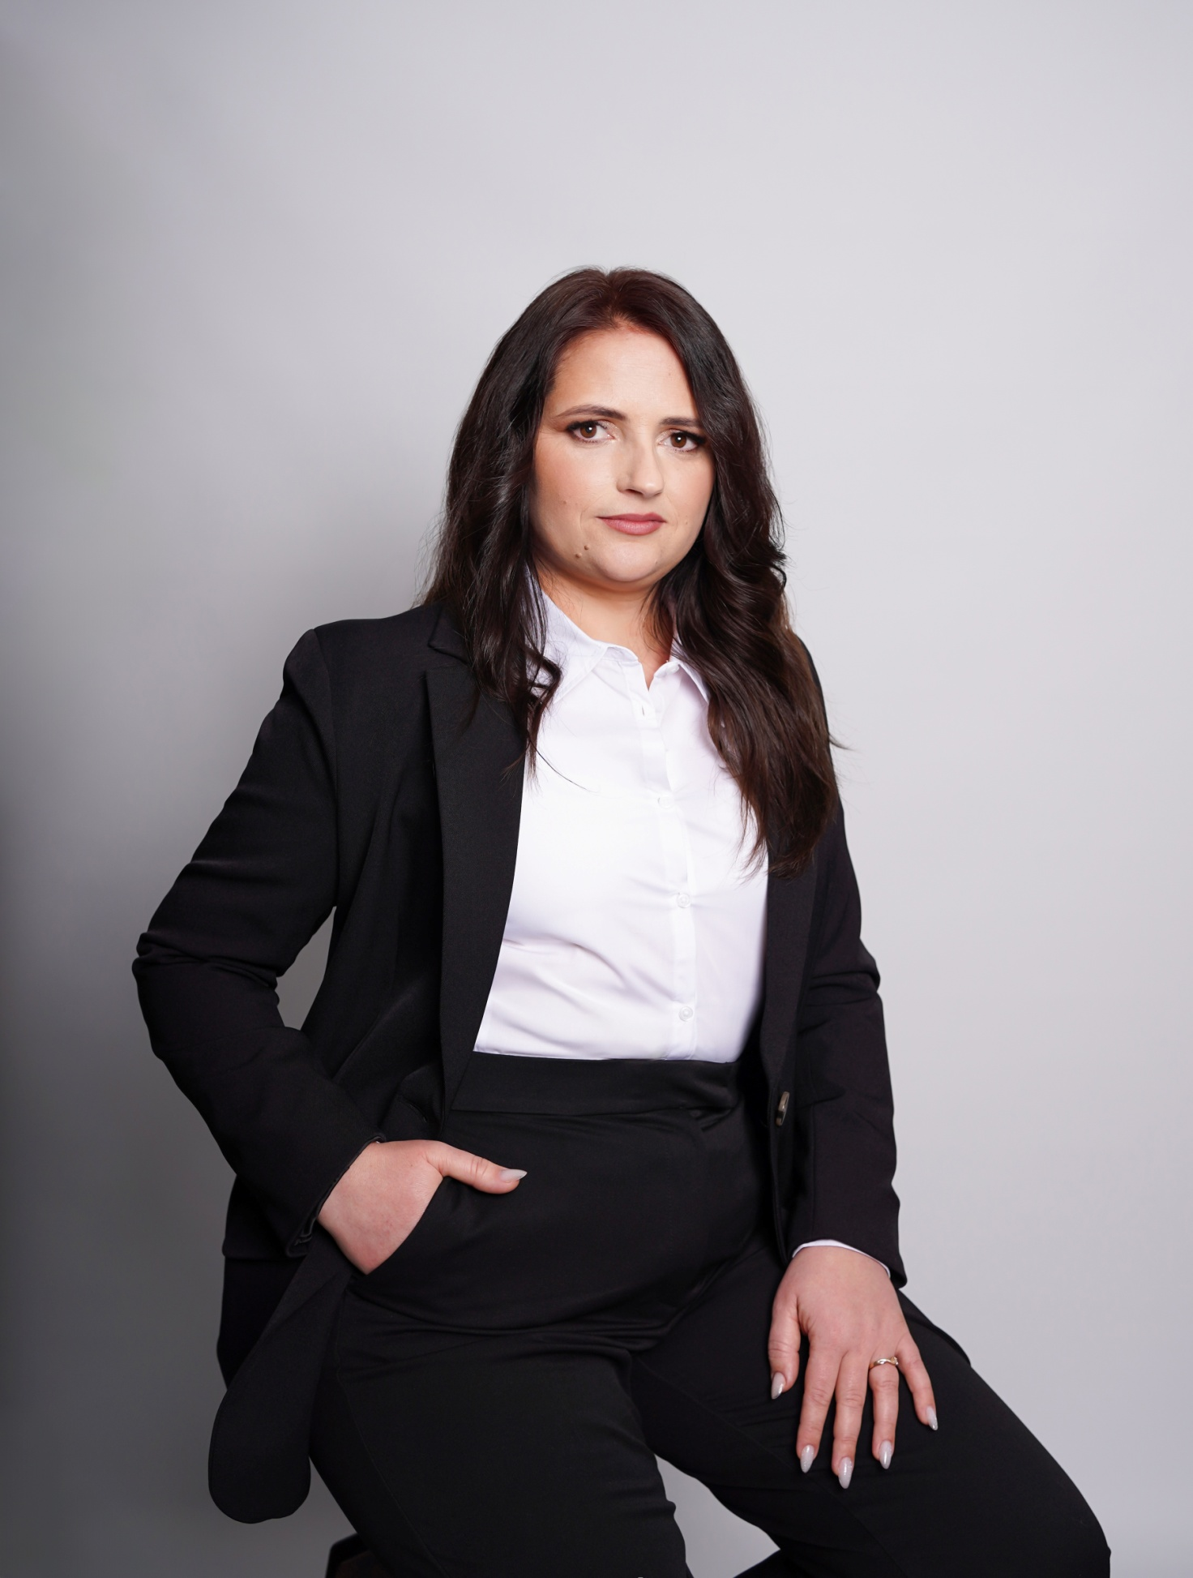

Meet Lola – Nail Technician
With over 10 years of experience in the nail industry, Lola has built a reputation for her exceptional craftsmanship, professionalism, and unwavering attention to detail. Her passion for creating flawless nails is reflected in every service she provides, making her one of the most trusted technicians among her clients.
Known for her perfectionist approach, Lola believes that every manicure should combine beauty, precision, and durability. Whether creating a timeless, elegant set or a bespoke nail design, she works meticulously to ensure each client leaves with nails that not only look stunning but remain strong, healthy, and beautiful for weeks.
Her calm, patient nature, combined with her commitment to excellence, allows clients to relax and enjoy a truly luxurious salon experience. Lola continually refines her skills, embraces new techniques, and stays up to date with the latest industry innovations, ensuring every treatment is delivered to the highest professional standard.
Fluent in English, Russian, and Ukrainian, Lola welcomes clients from diverse backgrounds and is dedicated to providing a personalised experience where every client feels comfortable, valued, and cared for.
At LUNA Beauty Studio, Lola takes pride in delivering beautiful, long-lasting results while building lasting relationships through trust, quality, and exceptional client care.

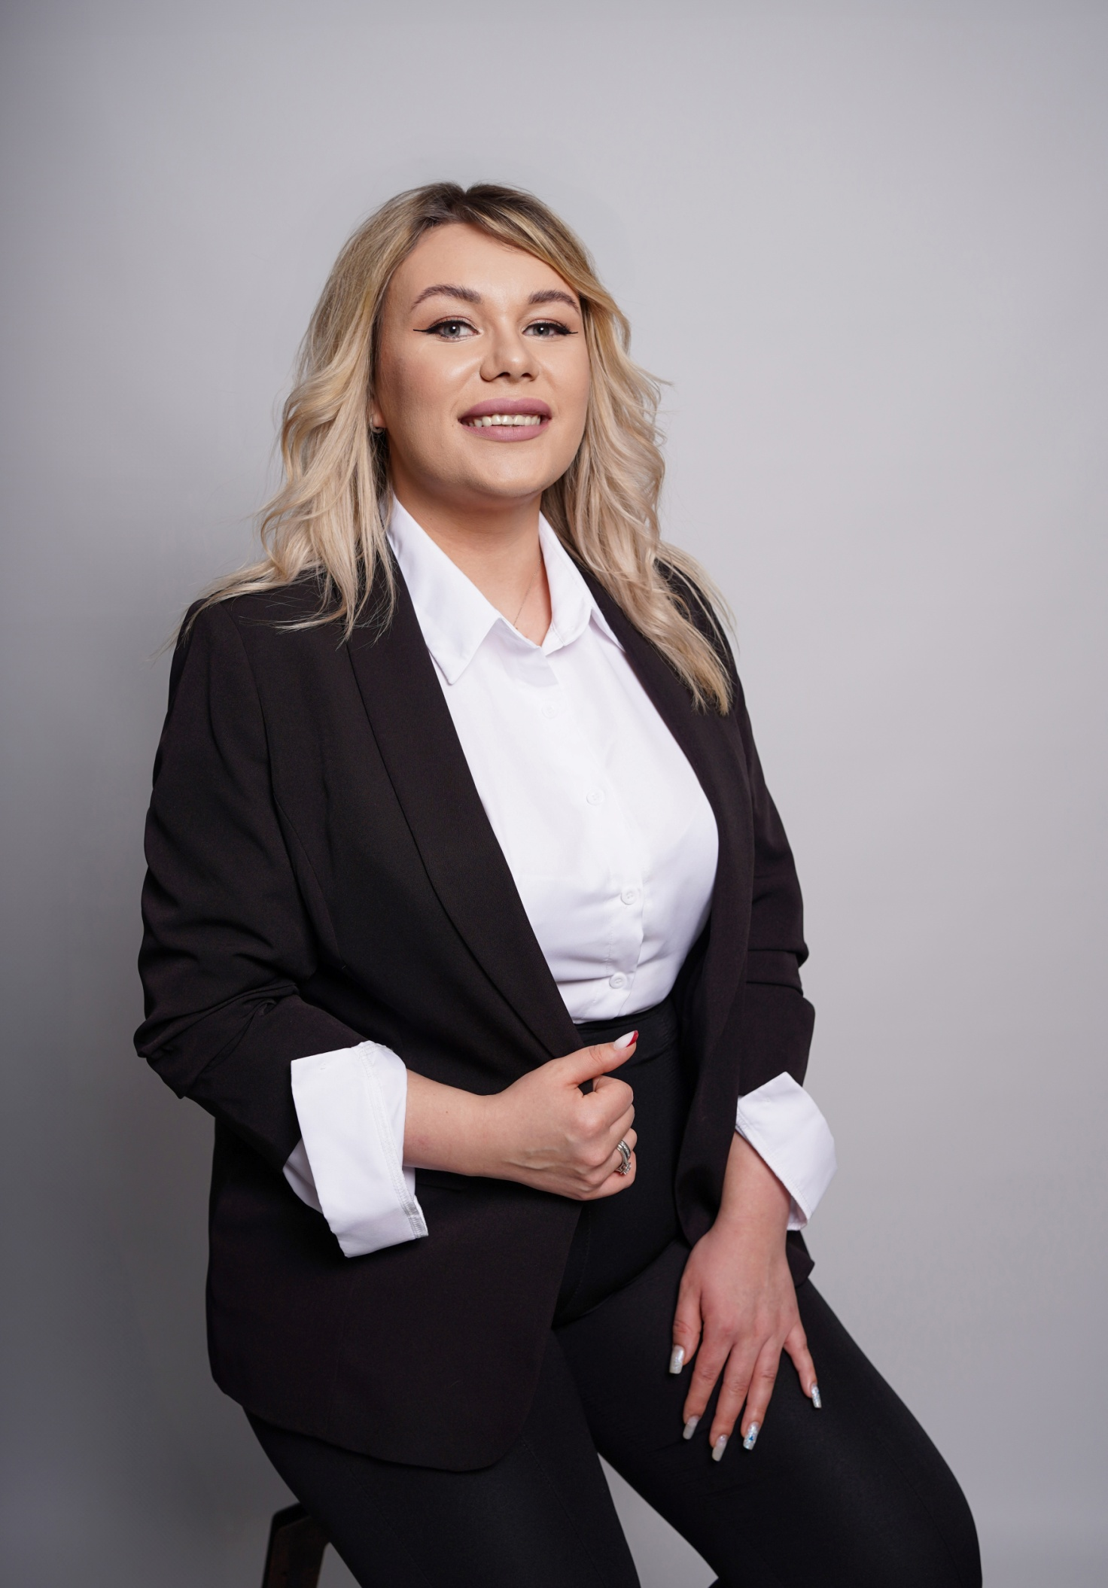

Meet Maryna – Brows & PMU Specialist
With over 10 years of experience in the beauty industry, Maryna is a highly skilled Brows and Permanent Makeup Specialist, recognised for her precision, artistry, and exceptional client care. Her passion lies in creating beautifully balanced brows that enhance each client's natural features while preserving their individuality.
Specialising in Brow Shaping, Brow Lamination, Powder Brows, and the latest Hair Stroke Brows technique, Maryna offers bespoke treatments designed to achieve the most natural-looking results. Using an advanced single-needle technique, Hair Stroke Brows create ultra-fine, realistic hair-like strokes with minimal skin trauma, helping restore the appearance of naturally full brows with exceptional softness and precision.
Known for her meticulous attention to detail and warm, reassuring approach, Maryna takes the time to understand every client's goals, ensuring each treatment is tailored to complement their facial features and lifestyle. Her expertise in client communication allows every appointment to feel relaxed, informative, and enjoyable, leaving clients feeling confident, beautiful, and delighted with their results.
Fluent in English, Russian, and Ukrainian, Maryna welcomes clients from all backgrounds and is dedicated to providing a luxury experience built on trust, professionalism, and outstanding results.
At LUNA Beauty Studio, Maryna is proud to combine advanced techniques with artistic precision to create naturally beautiful brows that help every client look and feel their very best.
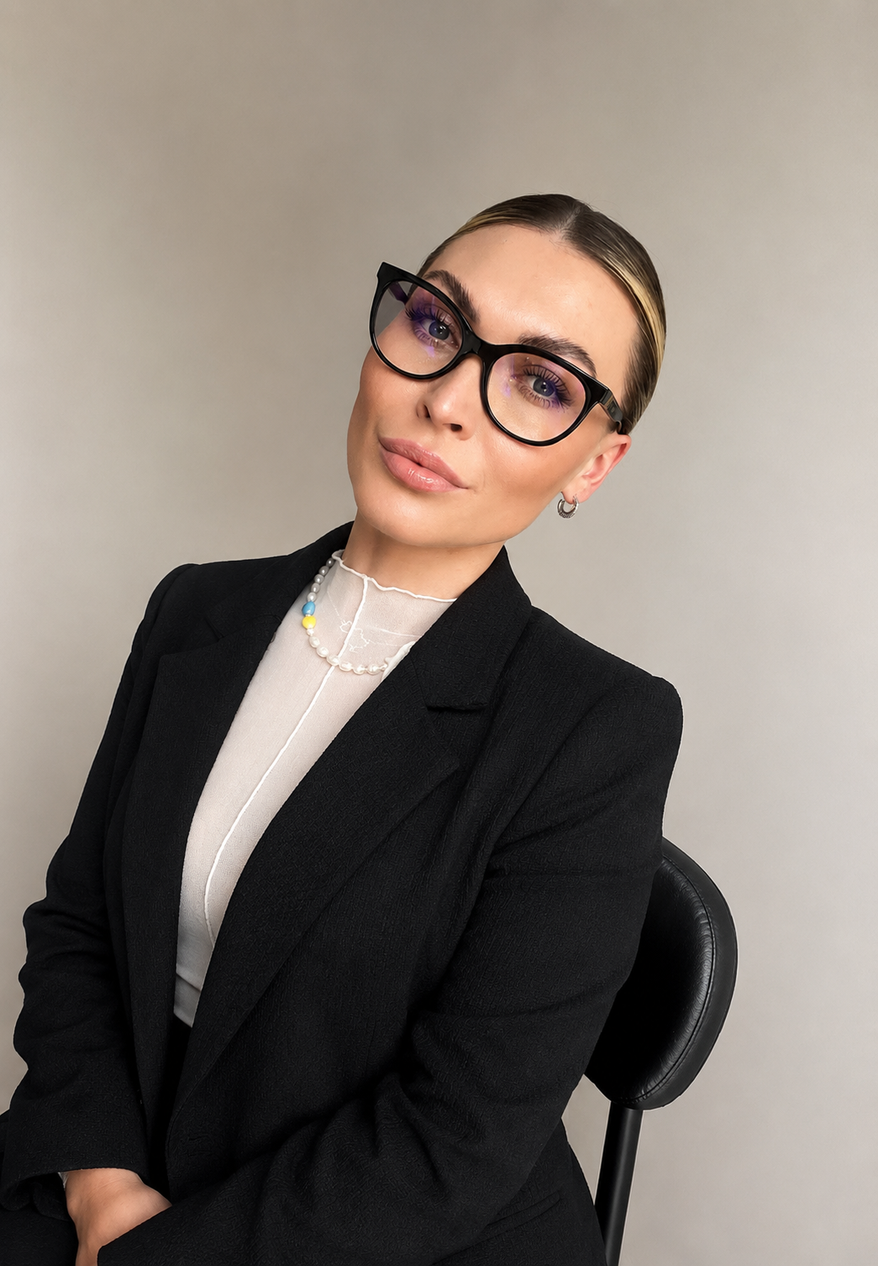

(foto not included)

Meet Nataliia – Waxing Specialist
With over 6 years of experience in professional waxing, Nataliia is dedicated to helping clients feel confident through beautifully smooth skin and exceptional client care. Known for her meticulous technique, professionalism, and impeccable hygiene standards, every treatment is performed with precision, care, and attention to detail.
Alongside a successful career in Business Management, Nataliia chose to follow her passion for the beauty industry, allowing her to combine her professional expertise with a genuine love for helping people feel their best. Her strong organisational skills, reliability, and commitment to excellence are reflected in every client experience.
Nataliia believes that waxing should be as comfortable and stress-free as possible. Her calm approach, excellent etiquette, and client-first mindset help even first-time clients feel relaxed, informed, and completely at ease throughout their appointment.
Fluent in Ukrainian and Russian, and currently developing her English language skills, Nataliia enjoys welcoming clients from diverse backgrounds and is continually expanding her knowledge to provide the highest standard of care.
At LUNA Beauty Studio, Nataliia is proud to deliver professional waxing treatments with precision, compassion, and outstanding attention to detail, helping every client leave feeling confident, comfortable, and beautifully cared for.
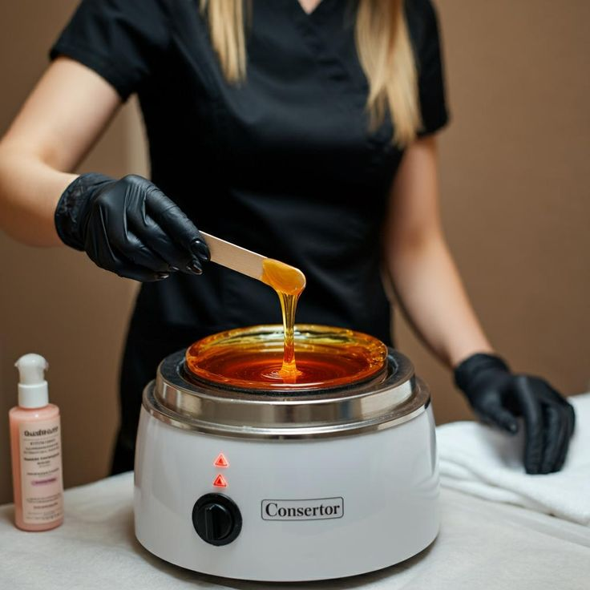

Experience professional waxing in a private, welcoming environment where your comfort is our priority. At LUNA Beauty Studio, we use premium-quality waxes and meticulous techniques to ensure effective hair removal with minimal discomfort while respecting even the most sensitive skin.
Every appointment is performed with the highest standards of hygiene, discretion, and professionalism, leaving your skin beautifully smooth for weeks. Whether you're booking your regular maintenance or your first waxing appointment, you'll receive personalised care and expert advice tailored to your skin and hair type.
Our goal is simple: to make every waxing experience comfortable, efficient, and confidence-boosting.
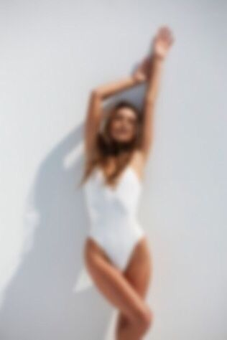
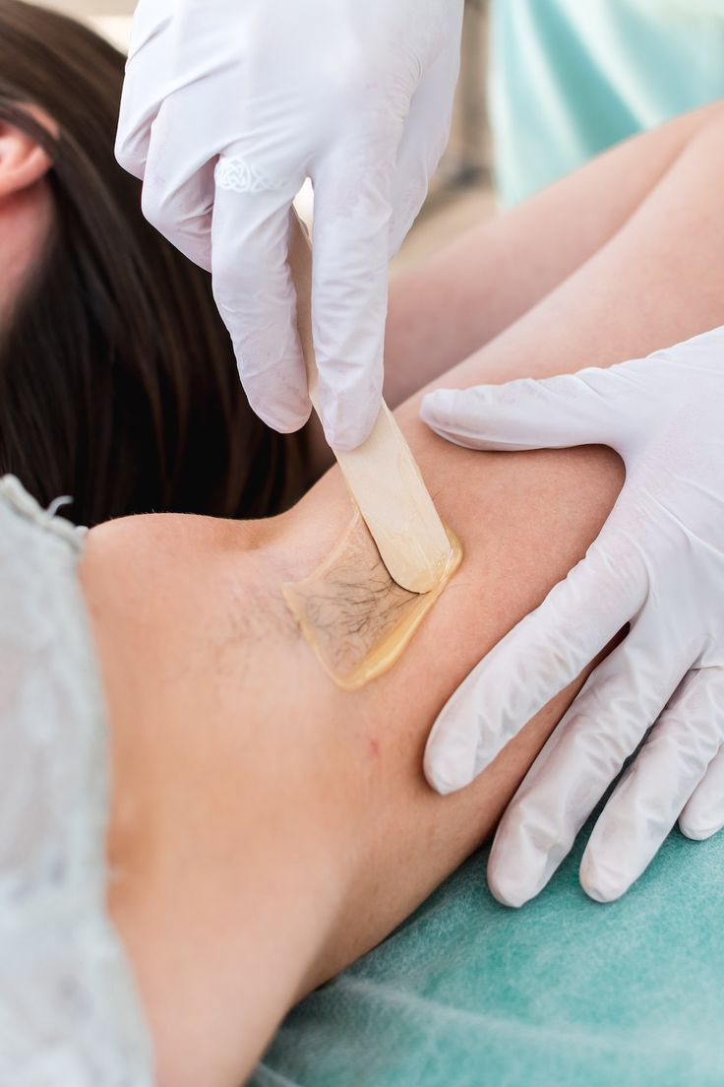
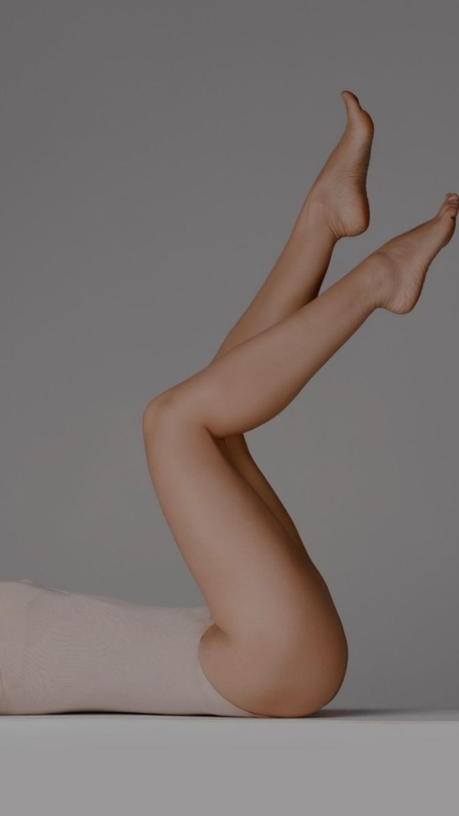

Brows & Lash Treatments

Enhance Your Natural Beauty
Beautiful brows and lashes have the power to transform your entire look. At LUNA Beauty Studio, every treatment is tailored to your unique facial features, creating results that enhance your natural beauty while remaining elegant and effortless.
Whether you're looking for perfectly sculpted brows, fuller-looking lashes, or a low-maintenance beauty routine, our experienced artists use premium products and advanced techniques to achieve long-lasting, natural results.

HD Brows

A bespoke brow treatment combining professional mapping, waxing, shaping, tinting, and styling to create brows that perfectly complement your facial features. Designed to deliver a polished, symmetrical look while maintaining a natural appearance.

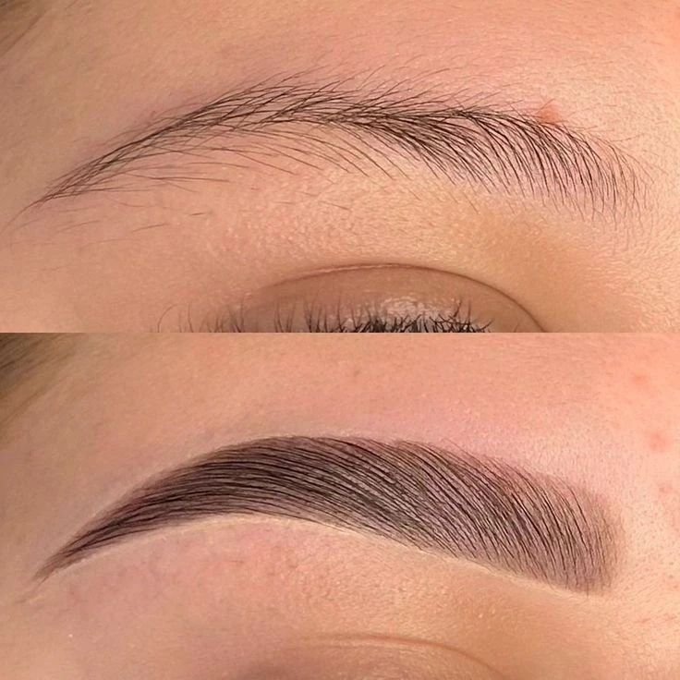
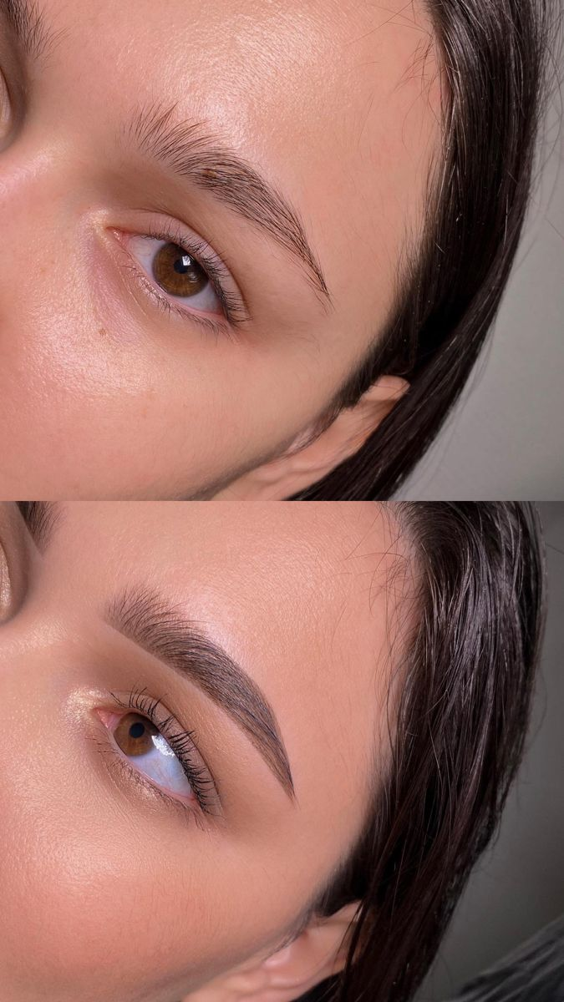

Brow Lamination
Transform unruly or sparse brows into fuller, perfectly groomed brows that stay in place for up to 6–8 weeks. Ideal for creating a soft, fluffy, and naturally lifted look.

Lash Lamination
Enhance your natural lashes with a beautiful lift, curl, and definition without the need for extensions. This treatment opens the eyes, creates the illusion of longer lashes, and lasts up to 6–8 weeks.
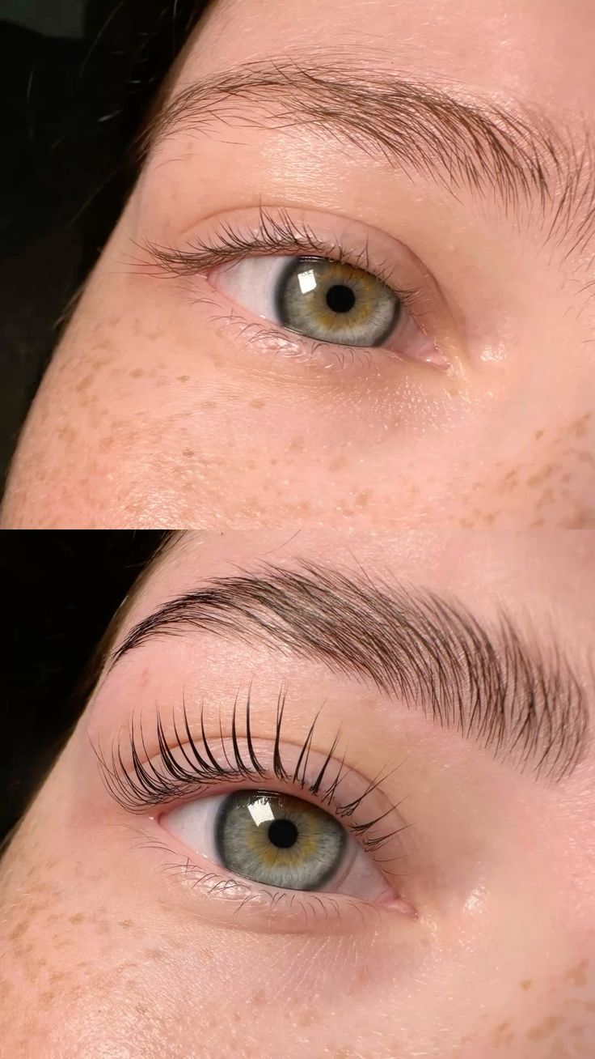
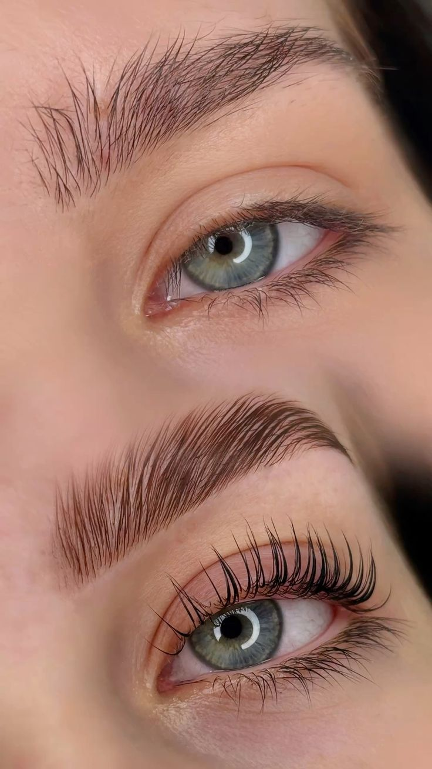

Permanent Makeup

Wake Up Beautiful Every Day
Permanent Makeup is designed to enhance your natural beauty while simplifying your daily routine. Every procedure is individually tailored to create elegant, soft, and natural-looking results that complement your facial features.

Powder Brows
A soft shading technique that creates beautifully defined brows with a natural powdered makeup effect. Ideal for clients looking for fuller, more symmetrical brows that remain effortlessly beautiful every day.
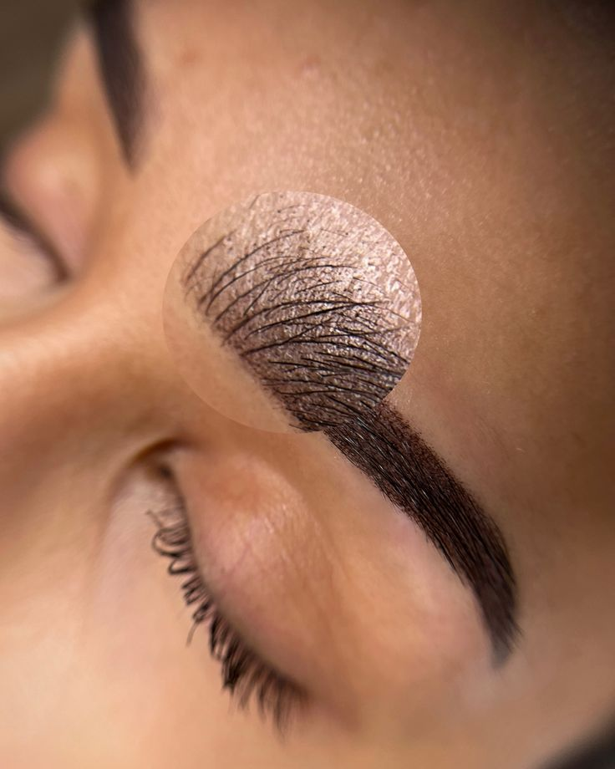
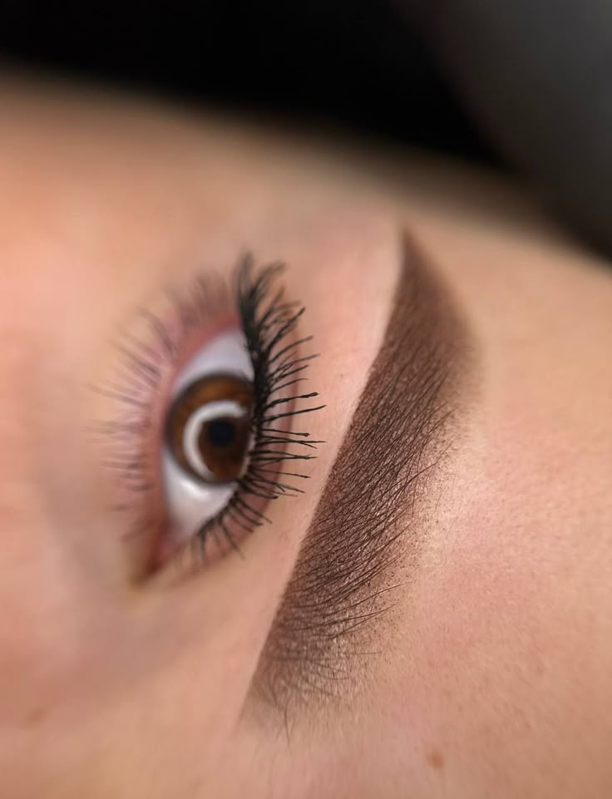

Hair Stroke Brows
Discover the newest generation of Permanent Makeup.
Using an advanced single-needle technique, ultra-fine hair strokes are carefully created to mimic natural eyebrow hairs with exceptional precision. This innovative method causes minimal skin trauma while delivering beautifully realistic, soft, and natural-looking brows that blend seamlessly with your own.
Perfect for clients with sparse brows or anyone looking to restore their natural appearance.
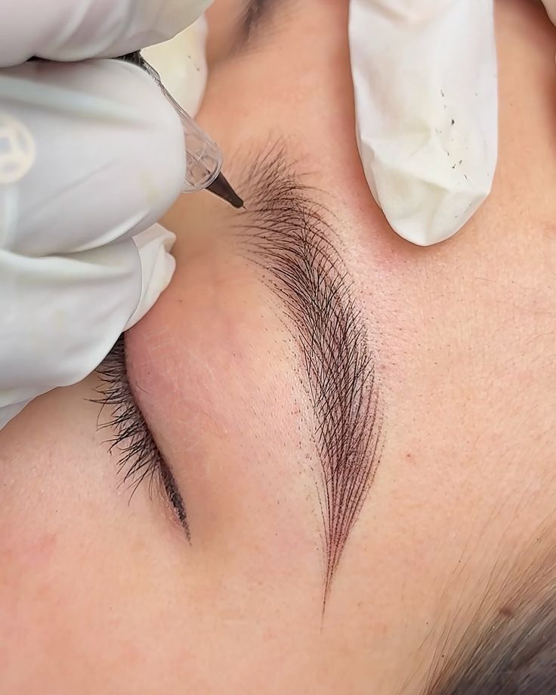

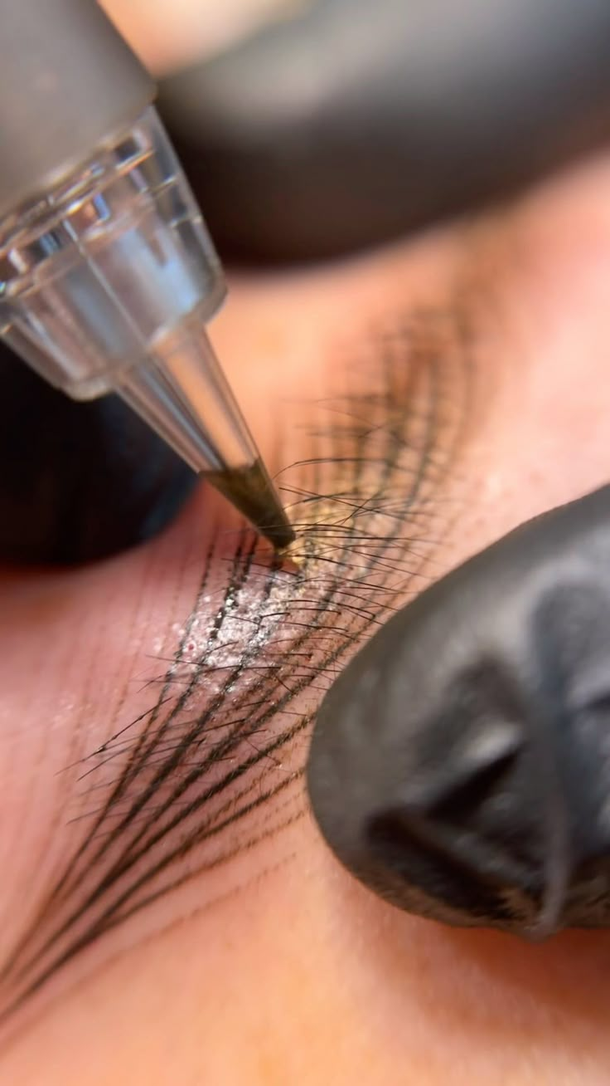

Lip Blush Wake up every day with beautifully enhanced, naturally tinted lips. Lip Blush is a semi-permanent makeup treatment designed to restore colour, improve definition, and create the appearance of healthier, more youthful lips. Using premium pigments and a personalised colour match, this treatment subtly enhances your natural lip tone while correcting uneven pigmentation and refining the lip border. The result is a soft, fresh finish that complements your features without looking overdone. Perfect for anyone wanting naturally beautiful lips with less daily makeup and long-lasting, effortless colour.
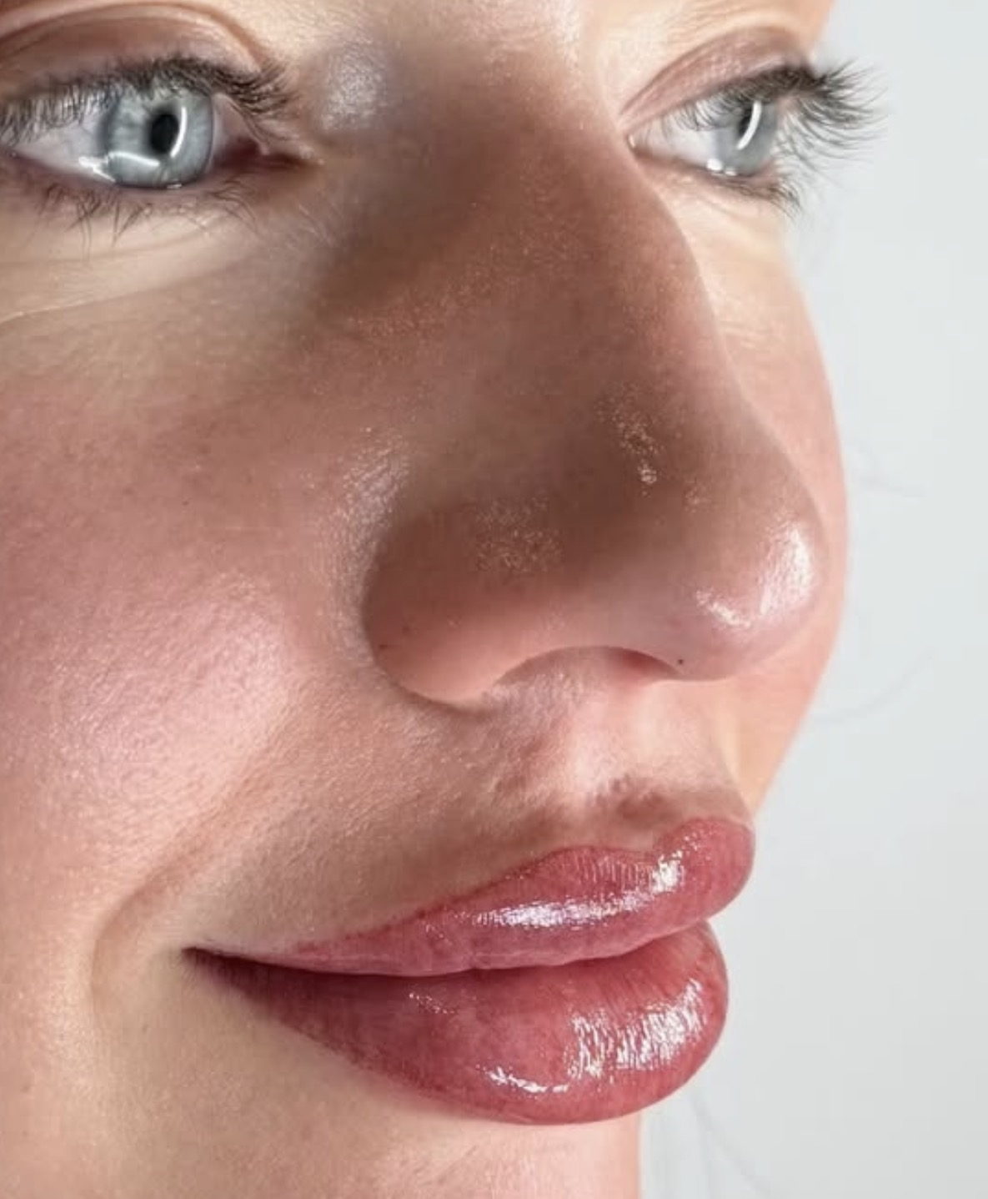

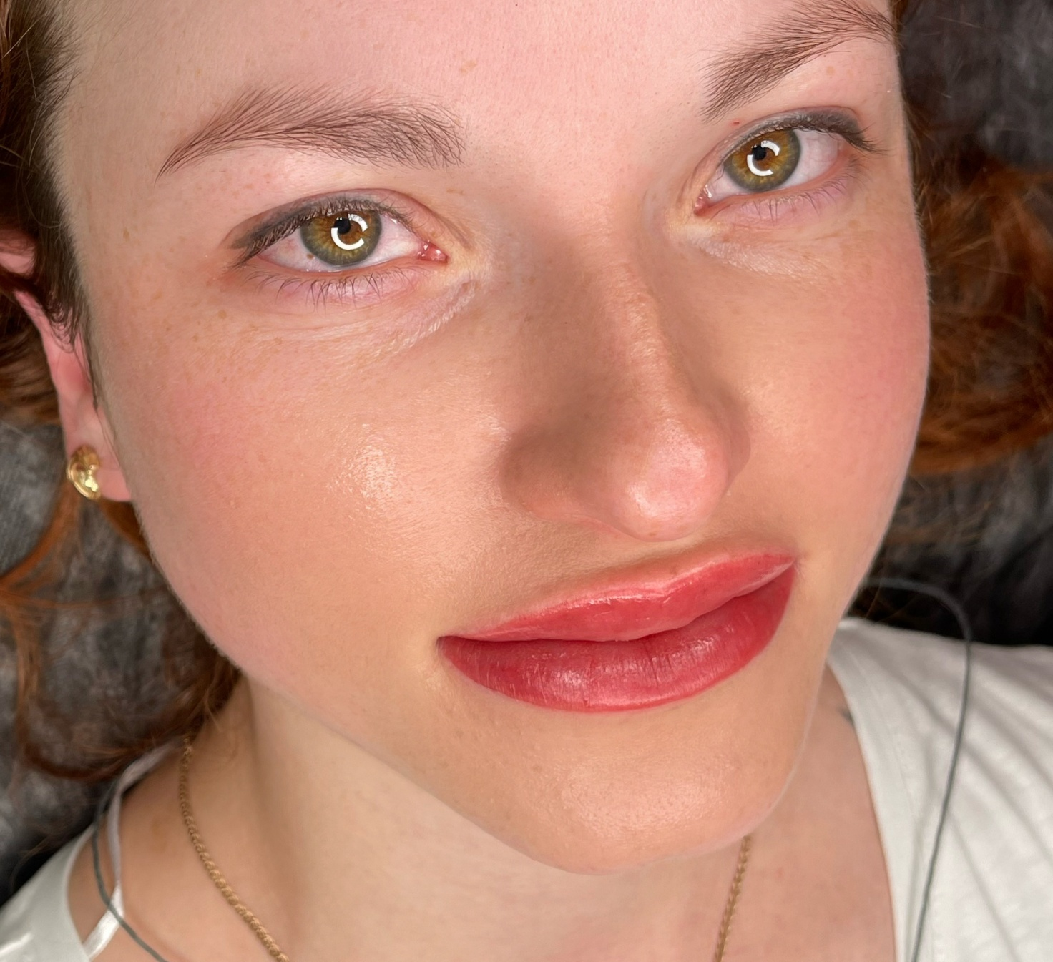

Why Clients Choose Us
✔ Personalised consultation for every client
✔ Premium pigments and professional products
✔ Advanced techniques for natural-looking results
✔ Luxury, private treatment environment
✔ Experienced specialists with meticulous attention to detail
✔ Beautiful, long-lasting results tailored to you

